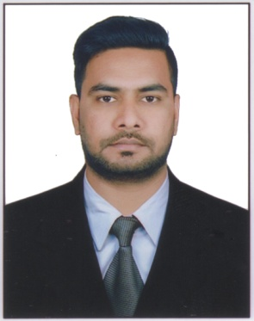
CURRICULUM VITAE

AZIZ
Email: mohammed.343987@2freemail.com
C/o-Contact No:+971-504973598
Visa Type: Visit Visa

PROFESSIONAL OBJECTIVE:

Seeking challenging position with immense scope for organizational and personal development and to earn appreciation from my colleagues and employers through my performance that I am going to achieve through my hard work, skill and zeal.

ABOUT MYSELF:

An enthusiastic, confident and committed young man with learning attitude and willingness to work on variety of assignments.

EDUCATIONAL QUALIFICATION:

- S.S.C. (Board of Secondary Education) from St. Marks Boys Town High School, Jahanuma, Hyderabad.
- Intermediate (Board of Intermediate Education) from Madina Vocational Junior College, Charminar, Hyderabad.
- B.Com (Osmania University) from BJR Degree College, Bazarghat, Hyderabad.

WORK EXPERIENCE:

- Worked as a “Customer Relation Officer” in Hinduja Global Solutions, Somajiguda, Hyderabad for a period of 1 Year since 2013 to 2014.

- Worked as a“Assistant Accountant” in, Wonder World, Hyderabad for a period of 2 Years since 2014 to 2016.

TECHNICAL QUALIFICATION:
- Accounting Package
- M.S Office
- Internet Browsing.
- Operating System (Windows 95/98/2000/XP)

PERSONAL STRENGTH:

- Quick Learner
- Effective Leadership Qualities
- Self learning capability and zeal to learn new things
- Willing to go any length to complete any task.

PERSONAL DETAILS

Sex : Male
Date of Birth & Age : 20th July 1988
Marital Status : Single
Religion : Islam
Nationality : Indian
Languages Known : English, Hindi, and Urdu.

PASSPORT DETAILS:

Place of Issue : Hyderabad, India
Date of Issue : 28/12/2016
Date of Expiry : 27/12/2026

DECLARATION:

I hereby declare that the above information and particulars are true and correct to the best of my personal knowledge and belief.

