Ahmed
Costumer service/sales (6 years)

Phone: +971 505891826 Email: ahmed.343991@2freemail.com
Address: International City, Dubai, UAE

Birth date: 8/9/1990
UAE Driving License

Personal Profile/Career Objective
I am a hardworking, honest individual, a good timekeeper, always willing to learn new skills, friendly, helpful, polite, have a good sense of humor. I am able to work within a team setting and able to listen effectively when solving problems.
Seeking a position with reputed company utilizing several skills in customer service, hospitality and demonstrated ability to remain calm in emergency situations.

Experience

2015– Present |  |  | Etisalat UAE  customer service\sales  Dubai, UAE  Attracts potential customers by answering product and service questions; suggesting information about other products and services. Opens customer accounts by recording account information. Maintains customer records by updating account information. Resolves product or service problems by clarifying the customer's complaint; determining the cause of the problem; selecting and explaining the best solution to solve the problem; expediting correction or adjustment; following up to ensure resolution.
2012 - 2015 |  |  | Abu Dhabi Distribution Co. customer service  Abu Dhabi, UAE  Customer service, listening to costumers, solving their problems, writing reports and emails to high management of the daily work evaluation.
2009 - 2011 |  |  | Egypt Air  Cairo International Airport  Ground Handling, Tickets booking & Public relations.
 |  |  | 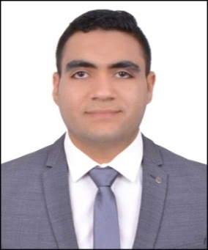

Education
Bachelor of hospitality management
Faculty of Tourism and Hotels El-Minya University, Egypt
Grade degree: good
Grade of project: Excellent
Graduation: 2011

Courses
Customer Services
Egypt Air, Cairo, Egypt
2010

Amadeus Reservation
Amadeus, Cairo, Egypt
2011

General of Public Relations
Egypt Air, Cairo, Egypt
2015

Sales
Etisalat, UAE.
2015

Languages
Arabic
English
Italy

Skills
Microsoft office
Soft Skills
Presentation Skills
Leader Ship

