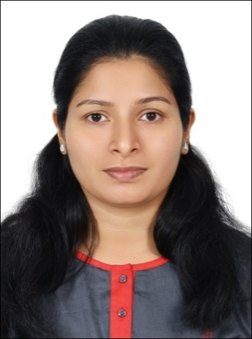
CURRICULUM VITAE

ARCHANA
C/o-Ph.+971501685421
Email: archana.344029@2freemail.com

Objective

Targeting to associate with an organization which provides me an opportunity toshow my skills and improve my competencies.

Professional and Academic Background

- Bachelor’s Degree in Nursing (BSC Nursing)
SreeDeviCollege of Nursing Mangalore
(Rajiv Gandhi University of Health Sciences Karnataka)
From Nov2002-Nov2006

- Higher Secondary Examination Govt of Kerala
From 2000-March 2002

Nursing Registration

- Registered Nurse,Federal Department of Nursing, UAE
- Registered Nurse and mid wife under Nursing Council India in 2007.
- Registered Nurse and mid wife under Karnataka nursing council India in 2007.

Work Experience

- Worked as a staff nurse (CCU) in VIMS Hospital,Marathahalli, Bangalore. (December 2014 to December 2016)

- Worked as a registered nurse in Sharjah kindercare nursery, Sharjah, UAE(March2013 to November 2014)

- Worked as a staff nurse in GMC Hospital, Ajman, UAE (January2011 to May2011).

- Worked as a staff nurse in Zulekha Hospital Sharjah (June2010 to October2010).

- Two years of experience as a Staff Nurse in Indira Gandhi Co-Operative Hospital Thalassery, Kerala, India.(November 2006 to November 2008).

Duties Undertaken

- Responsibilities for delivering and maintaining highest possible standards related to patient’s welfare in the unit.
- Perform periodic assessment and re assessment of patients in the unit.
- Plan, implement and evaluate nursing care rendered.
- Nursing documentation in brief accurate and complete manner.
- Initiate CPR during cardio pulmonary arrest.
- Assist for intubation.
- Preparation and aftercare of patient with PCI.
- Maintain the inventory of instruments, equipments and consumables.
- Administration of medication as ordered by the doctor.
- Actively participate in service education.
- Provide health teaching for the patient and their family.
- Work independently with other health professional.

Equipments Handled

- Cardiac Monitors, Defibrillator, Ventilators, Infusion Pump, Nebulizer, pulse Oxymeters, Glucometer, Suction Machine and ECG Machine.

Languages Known

- English, Hindi, Malayalam& Tamil.

Hobbies and Personal Strength

- Hobbies include Traveling, Chess and Listening to music.
- Ability to learn new skills, adaptable to any project with full enthusiasm and
- Good team work.

Personal Details

Date of Birth : 17.07.1985
Gender : Female
Marital Status : Married
Nationality : Indian
Religion : Christian
Visa status- visit visa

ARCHANA

