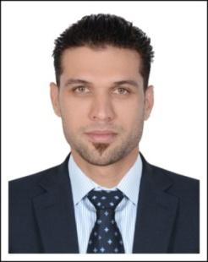
SANA
Accounting professional

C/o-Mob: +971504973598, E-mail: sana.344075@2freemail.com
UAE: Driving License Holder.
Summary:
A talented and accomplished Management professional with extensive financial and accounting background. MBA in (Finance) with more than 4 years of experience. Proven ability to establish and direct accounting departments and corporate finances. Able to develop and implement effective policies and procedures. Adept at re-organizing financial processes to improve efficiency, accuracy, and productivity. Highly familiar with supervising accounts payable / receivable, payroll, cash receipt, accrual, general ledger, reconciliation, collections, and other functions. Excellent presentation and communication skills.
professional experience
khan meer kheer transport LLC (Dubai).
- Position: Accountant. 2009 - 2011
- Preparing Invoices/Quotation as per the customer requirements
- Managing Petty Cash for different purpose.
- Using computerized accounting systems to maintain accurate records.
- Preparing wages and managing claims for expenses.
- Reconciling monthly statements.
- Processing all refund requests.
- Bank Reconciliation at the end of the month.
- Performing any other related duties as assigned by the Senior Accountant.
- Follow-up client’s outstanding balance.

O.K Furniture & Chairs LLC (Dubai)
- Position: Accountant. 2013 – 2015
- Managed accounts payable, accounts receivable, and payroll departments.
- Preparing sales invoices & the upkeep of an accurate accounts filing system.
- Post and process journal entries to ensure all business transactions are recorded.
- Maintain various types of vouchers.
- Preparation of various reports for management.
- Receive & Issue LPO as required.
- Bank reconciliation at the end of the month.
- Follow up Account receivable and sending updated SOA to customers.
- Assist in the processing of balance sheets, income statements and other financial statements.
- Managed the internal and external mail functions.
QUALIFICATION:
MBA in (finance) .Abdul Wali Khan University Mardan Pakistan. 2010- 2013
Computer Skills:
Microsoft Office, Tally, Quick book & Peach Tree.
Languages:
English /Urdu/Pashto
Reference – Available on request.

