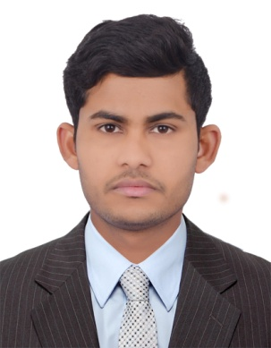
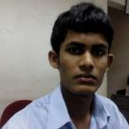

Contact HR Consultant for CV No: 2064540
E-mail: response@gulfjobseekers.com
Website: http://www.gulfjobseeker.com/employer/cvdatabasepaid.php

CAREER OBJECTIVE:

Seeking a Challenging and Responsible, where my education, experience and personal capabilities would be utilized to assist the organization in conquering its business challenges and I would like to make a significant contribution to Company that offers a genuine opportunity for progression

PROFESSIONAL EXPERIENCE:

(Dubai)
Date of Employment : 13-Aug-2013 to Till date
Designation : Retail sales clerk

Responsibilities:

- Right Merchandise - Styles, brands, colors’, sizes etc
- Right Place - Which store, depending on their budget and location
- Right Time - Having merchandise in stores at the right time in the season i.e. ready for Christmas or 'Back to School'
- Right Quantities - Enough for the stores to make their budgets but not have to markdown stock at the end of the season
- The Right Price - Those that will attract customers in spite of competition yet generate a reasonable return handling cash.
- Make sure SKU are correctly scan and check the prices.
- Make sure customer got change and receipt.
- Handling customer service
- Manage receipts and coupons
- Balance all reports with daily balances
- Handling everyday Minimum 450 customer
- Reduced waiting time for customers by providing quick services

LB Finance(Sri Lanka)
- Date of Employment : Jan-2011 to Feb 2013
- Designation : Marketing officer cum Customer relation officer

Responsibilities:

- Each Day updating sales report to the management
- Maintenance of company documents
- Supporting the marketing manager in day to day marketing activities.
- Plan, develop and deliver campaigns as agreed within timescales.
- Develop and maintain sales cash flows to ensure that forecast sales targets are met

SCHOLASTICS:

- Diploma in Business and Information Technology from Siksil Institute in of Information & Technology (Pvt) Ltd.

PERSONAL DETAILS:

Date of Birth : 03 Jan 1991
Nationality : Sri Lankan
Gender : Male
Marital Status : Single
Known Language : English

DECLARATION:

I do hereby solemnly declare that all the information provided herein before is true and correct which I can illustrate / discuss / produce evidence / testimonials thereof, as the case may be and as desired.

:

