344121@gulfjobseekers.com

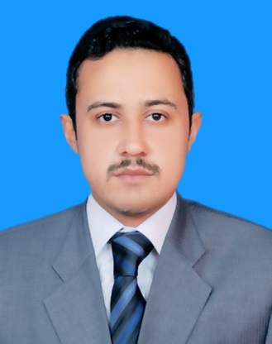

OBJECTIVE:

Seeking a position where my, skills and knowledge can be utilized effectively and in the best interest of the organization and its shareholders which make me an outstanding performer in organization.

EDUCATION:
Bachelors of Arts (BA) Part First University of Swabi .

Chartered Certified Accountant (ACCA) (UK) (finalist)

Certified Accounting Technician (CAT) (UK) .

Higher Secondary School Certificate
Board of Intermediate and Secondary Education Mardan
(1st Division) .

Secondary School Certificate
Board of Intermediate and Secondary Education Mardan
(1st Division)

EXPERIENCE:
Entity: Mushtaq Akbar & Co CHARTERED ACCOUNTANTS
A member firm of INPACT Asia Pacific
AREA: AUDIT AND ASSURANCE
POSITION: AUDIT AND CONSULTANCY SEMI SENIOR
REPORTING TO: ASSURANCE MANAGER & PARTNER
PERIOD: July 2013 to 31th January 2016

2.5 years of extensive training, as required under C.A Bye-laws (Pakistan). The experience of audits coupled with corporate and secretarial practices has enhanced my professional capabilities. During my professional association with firm, I have undertaken a diverse range of assignments and performed statutory and non-statutory audits and other assignments relating to various organizations. Which include book keeping, initiating from journal entry to preparation of full set of financial statements comprising of, balance sheet, profit loss accounts and cash flow statements.

Assignments conducted also required ensuring compliance with International Accounting Standards (IAS), International Financial Reporting Standards (IFRS) and other Reporting frameworks.

Brief summary of sectors where accounting and audit assignments carried out are in Manufacturing companies, Governmental Organizations , Non- Government Organizations (both international and local), Service Sector , Construction (both international and local)

ACCOUNTING SOFTWARES:

- Proficiency in use of MS Excel, MS Word, and MS PowerPoint
- Quick Books

BEHAVIOUR:
- Honest.
- Professional.
- Believe on hardworking and learning.
- Strictly follow the IFAC code of ethics i.e. Integrity, Confidentiality, Professional behavior, Professional Competency & due care, and Objectivity.
- Believe in continuous improvement

INTERESTS:

- Reading books and newspapers.
- Running, football.
- Internet surfing and music.
- Study History

REFERENCE:

Should be provided when required

