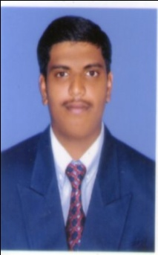
Curriculum Vitae
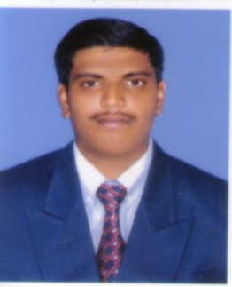
Faizal
Email: faizal.344197@2freemail.com

Objective
Seeking for a challenging and rewarding opportunity in an organization to utilize my true potential and nurture my excellent analytical and technical skills in IT Industry. To acquire an entry-level position in networking field where I could enhance my skills along with serving the company for better growth.
Career Summary
- Proficient in WAN and LAN technologies.
- Expert in configuring and installing CISCO Routers and switches
- Proficient in monitoring and troubleshooting the Network / Link in case of any breakdown
- Strong technical concepts
Personality Traits
- Exceptional presentation and interpersonal skills
- Able to handle the pressure situations
- Able to work individual as well as in-group
- Excellent communication skills in written and verbal both
Technical Skills
- Installing, Configuring and Troubleshooting of Networking Equipment's: Routers and Switches
- Managing, Maintaining and Configuring an Internet work with the help of WAN technologies like PPP, Frame-relay, dedicated T1s, ISDN and Routing Protocols: OSPF, EIGRP, IGRP, RIP and RIPv2. Introductory knowledge of Layer-2 Switching, VLAN’s and Access-list
- Good understanding of OSI Model, TCP/IP protocol suite (IP, ARP, ICMP, TCP, UDP, SMTP, FTP, TFTP)
- Well understanding of Bridging and switching concepts and LAN technologies
- IP addressing and sub-netting, Routing concepts
- Sound knowledge of routing protocols - RIP V1/V2, OSPF, IGRP and EIGRP
- Switches: Basic Configuration and VLAN setup on Cisco 1900, 2950, 2960, 3550, 3750, 4500, 6500 Switches
- Router: Basic Configuration and monitoring of Cisco 2500, 2600, 1800
- IP V4& IP V6- Switching: VLAN, VTP, STP, Ether channel, HSRP
- Hardware: Catalyst 2960/ 3550 / 3750/ 4500 / 6500 series switches
- Operating Systems: Cisco IOS, Windows Server 2003/2000/NT and Workstation
- Configured Cisco Routers (2500, 3000, 4000) using RIP, IGRP, OSPF, EIGRP
- Configure Cisco Switches (4500, 3550, and 2960)
- LAN/WAN design and implementation using Cisco routers, hubs and switches
- Securing network resources with shared folder permissions, Implementing file security system
- Languages : Visual Basic, C#,.NET (ASP.NET)
- Operating System : Windows professional/XP , Mac and MS-DOS.
- Hardware : Installation of all kind of Software,OS
Previous Employer
- Worked as a Network Engineer in TNQ Books & Journals from Aug 2013 to Sep 2016.
Education
- B.Sc Information Technology, Bharath College of Science & Management,Thanjavur.Affiliated to Bharathidasan University, (2010-13)
Additional Qualification
- CCNA- Cisco Certified Network Associate at RJP INFOTECH PVT LTD (Cisco Certification)
- .NET (VB.NET, ASP.NET, ADO.NET) at CCI Computer Education – Thanjavur.

Personal Details:
Date of Birth : 06-02-1993
Nationality : Indian (Muslim)
Marital status : Single
Languages known : English and Tamil
Hobby : Photography, Reading Books and Drawing

I hereby declare that all the above mentioned details are true and correct to the best of my knowledge and belief.

Place : Dubai
(Faizal)

