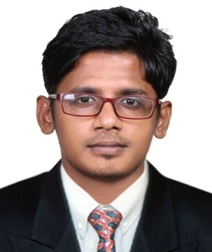
DIJO
Dijo.344202@2freemail.com

Objective:
Seeking a position as Mechanical engineer that allows application of my knowledge, good usage of my strengths and skills, exposure to most modern technologies and making a significant contribution towards the growth of organization.

Profile:

- Have 4.3 years of experience as Mechanical engineer in India.
- Hold a Bachelor of Engineer Degree in Mechanical Engineering.
- Excellent Communication skills in English, Hindi, Tamil & Malayalam.
- Can efficiently work in team & individually.
- Detail-oriented, efficient & organized professional with an extensive experience in engineering systems.
- Possess strong analytical & problem solving skills, with an ability to make thought out decisions.
- Resourceful in completing projects & efficient in multi-tasking.
- Have the ability to quickly identify problems as well as provide appropriate solutions.
- Energetic & self-motivated with a high degree of cultural sensitivity.
- Can work under pressure & meet deadlines.
- Hard working and willing to relocate.
- Planning the Shift Schedule
- Preparation of standard operating and maintenance procedures for various equipments
- Job handling communication with workmen for use of all SAEFTY PPE'S and SOP'S
- Completed Auto CADD foundation course.

Employment History:

- Mechanical Engineer, M/s. M.C.K Kutty & Company c/o Seas Goa Ltd, Goa, India. ( From February 2012 to July 2016)
Job Profile

Maintenance:

- Shutdown maintenance.
- Maintenance of Pumps and Valves.
- Routine maintenance of all Equipments.
- Maintenance of Air Blower.
- Condition monitoring of mechanical equipments.
- Vibration analysis of motor, pumps, fan and find out the problem.

Planning:

- Job Schedule and manpower distribution.
- Collecting the job status feedback.
- Preparation of manpower histogram.
- Preparation of delay with rectification plan.
- Conduct internal meeting and ensure the teamwork.
Utility Operation:

- Blower Operation.
- Operation of Complex water pump and firefighting pump hose.
- High pressure and low pressure pump operation.

Educational Attainments:

- Secondary School Leaving Certificate: General Education Department, Trivandrum,
Kerala. (March 2005).
- Higher Secondary Examination: Board of Higher Secondary Examination, Trivandrum,
Kerala. (March 2007).

Professional Attainments:

Bachelor of Engineer in Mechanical Engineering: Anna University, Trichy
(Theni Kammavar Sangam College of Technology, Theni – Tamil Nadu.) (June 2011).

Other Course

- Completed Auto CADD Foundation course in CADD Centre, Pala (January 2012).
Computer Skills:

MS Office, MS Word, MS Excel, MS Power Point

Personal Data

Date of Birth : 03rd June 1989
Nationality : Indian
Marital Status : Single
Declaration:
I hereby confirm that all the information provided above is authenticate to the best of my knowledge.

