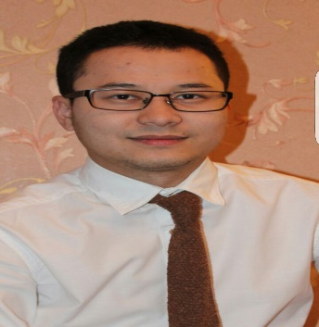 | Email: zhanbolot.344211@2freemail.com

Career objective:
To work for a progressive organization in a highly motivating and challenging environment that provides the best opportunities to grow and utilize my potential to the fullest to achieve the organization’s goals while achieving my personal goals.
Skills
Customer Service Professional Personal
Relationship building Process development Listening skills
Complain procedures Highly organized Customer engagement
Positive language Planning and Preparation Working with others
Telephone techniques Managing time Body Language
Effective questioning Troubleshooting Pro-active
Managing objection Negotiating skills Self-disciplined
Customer satisfaction IT skills Articulate
Web chatting Multi-tasking Tenacious

Education
January, 2013 – January, 2016 Kuala Lumpur, Malaysia
The University of Greenwich BA in Accounting and Finance

July, 2010 – July, 2011 Kuala Lumpur, Malaysia
Asia Pacific University of Technology & Innovation (APU) 1 year foundation program
Ratified by Staffordshire University, UK

September, 2005 – May, 2010 Bishkek, Kyrgyzstan
Kyrgyz-Turkish High School High school diploma

Work Experience
2011- 2016 (every summer) Waiter/ Guest Service
“Ak-maral” hotel Issyk-kul, Kyrgyzstan

September, 2011 – December, 2016 Assistant/ Supervisor
“Library” Greenwich University Kuala Lumpur, Malaysia
June, 2005 – July, 2010 Customer Service/ Sales
Ak-tilek Ltd textile chain company Bishkek, Kyrgyzstan

Computer skills
MS Windows, MS Office (Word, Excel, PowerPoint).

Languages
English - Fluent
Russian - Native
Kyrgyz - Native
Turkish - Upper Intermediate

Achievements &Awards
- Maybank GO Ahead. Challenge 2014 – Campus Level (Sunway) 2014
- ARC Teambuilding Camp at Asia Pacific University 2011
- Bizz Buzz Week at Asia Pacific University of Technology & Innovation 2011
- Member of Volunteering at SEGI Student Volunteers 2014-2015
- Diploma of Computer Sciences (Grade: Excellent) 2010
- Diploma of English Language (Grade: Excellent) 2010
- Diploma of Turkish Language (Grade: Excellent 2010

