AMEEN
AMEEN.344252@2freemail.com
RESUME
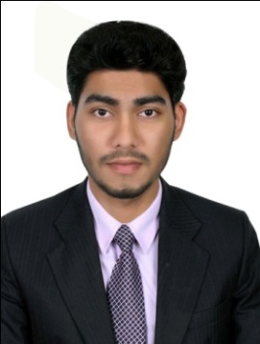 | Career Objective :  To obtain a challenging position that provides me opportunities to exploit my knowledge and extensive development skills to the extreme levels of my ability and to continually upgrade myself to the highest levels of expertise enabling the organization to achieve its target and growth.  Strength :  - Good interpersonal and communication skills.  - Be quick to learn with strong attention to detail.  - Very flexible and able to adapt quickly to a changing and fast–paced environment.  - Can work under pressure.  - Self motivated.  Academic Profile :  - Passed Bsc Biotechnology with in the year 2011 from Sree Narayana College of Technology, Ayathil.Kollam, under the University of Kerala.  - Completed the Certificated course in Diploma in Computer Application in the year 2011 Indian Computer Academy, Kottiyam, Kollam, Kerala-India  - Passed Higher Secondary with in the year 2009 from G.H.S.S, Pallimon, Kollam  - Passed Secondary School with in the year 2007 from T.K.M.H.S.S, Karicode, Kollam, Kerala – India.  Computer Skills :  - Technical/Graphic –MS Office, Adobe Photoshop, Tally, Internet Browsing.  Extra Curricular Activities :  - Active Participation in College Events.  - Designing.  - Reading.  Achievements :  - Won Prize for Arts Competition in School Level.  Personal Profile :  - Young, Dynamic, Dedicated and Determined.  - Self motivated and fast learner.  - Committed and result oriented.
Languages Known :

To Read : English, Arabic Hindi and Malayalam.
To Speak : English, Arabic Hindi and Malayalam.
To Write : English, Arabic Hindi and Malayalam.

Work Experiences :

- 2 Years Experience in DTP Operator in Soft Copy Map Centre UAE.
- 1 Years Experience in Marketing Executive in IBAJ Group of Companies Kollam

Declaration :

I, hereby declare that all the information given above are true and correct with the best of my knowledge and I bear the responsibility of the above mentioned particulars.

