CURRICULUM VITAE

DUBAI EXPERIENCE: 2 years
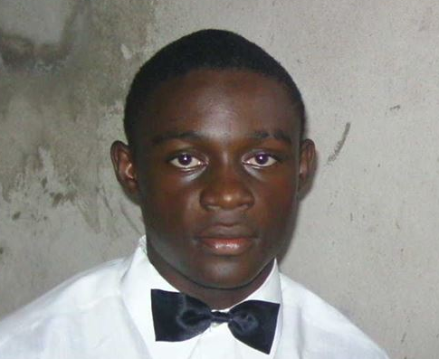
Name:TCHABO
D.O.B:
Marital status:single
C/o-Tel: +971502360357
Nationality: Cameroonian
E-MAIL: tchabo.344275@2freemail.com

COMPUTER NETWORK TECHNICIAN AND TELECOMMUNICATION.
LATEST SCHOOLS ATTENDED:
- D.I.T (Douala Institute of Technology);
- GUI / ISTA (InstituteUniversities Gulf of Guinea / Higher Institute of
Advanced Technologies).
SCHOOLS PATHWAY.
- 2012-2013: Bachelor of Engineering / Professional Degree in Network and
Telecommunication at D.I.T (Douala Institute of Technology)
- 2012-2013: PAME (Higher Diploma in Professional Studies) in Network and
Telecommunication GUI (University Institute of the Gulf of Guinea);
- 2009-2010: Baccalauréat D (G.C.E ADVNCED LEVEL) at "Lycée Mongo JOSEPH";
- 2008-2009: Probation Series D "Valley College";
- 2006-2007: BEPC the "college of the Valley";
- 1990-2001: CEPE (First School leaving certificate) at the "Ecole Privée Bilingual and the Source of Boko"

PROFESSIONAL EXPERIENCES.
- September 2014 till November 2016
- Assistance fitter in Dubai UAE
- Office boy
- secretary
- January 2014 to until now:
- Computer Teacher;
- Monitor and network technician cyber CYPRORES
- Technician computer network MULTITECH CENTER
- February 2013 to July 2014, trainee at JDDS / Guinness Cameroon S.A.
- Installation Ncomputing X550 Vspace software;
- Installation enterprise wired network;
- Installation of VoIP in the structure.
- July 2013 to December 2013, an intern at MULTITECH CENTER;
- Study and realization of a presence simulator;
- Installing taken networks;
- Programming in MPLAP.
- June 2012 to October 2012, an intern at EQUINOXE TV and Radio;
- Security of the company's computer network;
- Installation of video and sound; June 2011 to September 2011, an intern at BOUTIQUE REFERENCE.
IMPLEMENTATION, MANAGEMENT AND PARAMETER:
- Wired Network: Design, implementation and management (Wireless).
- Network security: Installing and managing firewall (firewall).
- Operating system Windows: 2003 Server, 2000 Professional, XP
Professional.
PROFESSIONAL STRENGTHS:
- Quick adaptation to editing software;
- Quick adaptation to simulation software;
- Host DJ party rooms;
- High reflection capacity;
- Spirit of increasing creativity;
PROFESSIONAL KNOWLEDGE:
- Computer Knowledge,
- Packet trace of Knowledge;
- Knowledge Sony Vegas Pro for video / audio editing;
- Knowledge of computer hardware;
- Starting in Photoshop;
- Experienced in office secretariat;
- Experienced in computer maintenance,
- Master Paint;
- Mastery of Word, PowerPoint, Publisher, Access and Excel;
- Computer network technician;
- Computer maintenance technician;
COMMUNITY LIFE:
- Founding member of the A.J.C.P (Youth Association of the POKOSSI City);
- Secretary General A.C.J.E.D (Community Youth Association
Enterprising and Dynamic).
LANGUAGES:
- English: speaking; read and write;
- Urdu: speaking
- Arabic: speaking
- French: speaking, reading and writing;
- German: Outstanding study.
HOBBIES:
Travel, football, music and reading.

I said exactly all information given in my CV.

