PRESENT ADDRESS

AYSHA
AYSHA.344303@2freemail.com

Date of birth : 03.08.1990
Sex : Female
Marital Status : Married
Nationality : Indian

AYSHA

AYSHA.344303@2freemail.com
CERTIFIED MEDICAL CODER
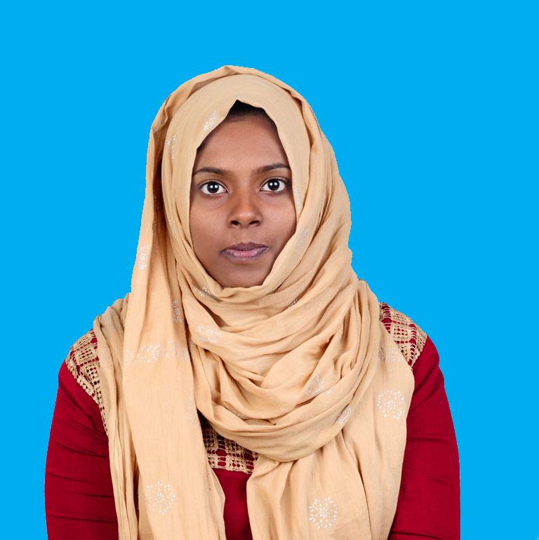

CAREER OBJECTIVE
Through constant learning, widen the horizon of my knowledge and achieve the best of abilities to develop my own achievement and sharpen my skills and utilize the same to the advantage of the organization and its surroundings. A position as an active employee involving responsibility and working with others as a team member to advancement, growth for the company.

PROFFESIONAL EXPERIENCES

- Well organized, self-motivated and hardworking medical/Insurance Coder with two year experience.
- Worked as a Medical coder, with Navigant India private limited (previously Revenue-med India private limited Trivandrum India), from 15th December 2014 to 6th February 2017.
- With 3 months of diversified experience as a project fellow in Regional Cancer Centre (RCC) Trivandrum.
- Project work is based on the anti-tumor activity pf polysaccharides, PSM and PSP on A549 lung cancer cell line.
- Good knowledge in cell culture, wound healing, Clonogenic assay, MTT assay.

EDUCATIONAL QUALIFICATIONS

COC Certified from (AAPC).
ICD-10 Profficient.
Msc Biochemistry
Board: Mahatma Gandhi University
St. Berchmans(S.B) collage Changanaserry.
Bsc Biochemistry
Board: Kerala University,
T.K.M Collage of Arts and Science, Kollam.
Plus Two
Board: Board of Higher Secondary Kerala
T.K.M Centenary Public School Kollam.
SSLC
Little Flower, E.M.H.S Edava,
Trivandrum. Kerala.

NATURE AND RESPONSIBILITY OF WORK

- Medical coding E/M, ED, ICD 9, ICD 10, CPT, HCPCS
- Outpatient and Emergency Department file coding.
- Documenting patient history and record making
- Assigning proper diagnosis and procedure codes
OUTPATIENT CODING KNOWLEDGE

- Expertise in medical record review to abstract information required to support accurate outpatient coding especially in Emergency Department.

- Expertise in assigning accurate ICD-10 medical codes for diagnoses and procedures performed in the outpatient setting.

- Superior knowledge of current rules and regulation, issues regarding medical coding, compliance, and reimbursement under MS-DRG and IPPS systems.

- Strong ability to integrate coding and reimbursement rule changes in a timely manner to include updating the Charge Description Master (CDM), fee updates, and the Field Locators (FL) on the UB04.

- Solid understanding of anatomy, physiology, and medical terminology required to correctly code facility services and diagnoses.

- Understanding of outpatient reimbursement methodologies (OPPS)

PROFESSIONAL LICENCES

- CERTIFIED OUTPATIENT CODER (AAPC)

- MEMBERSHIP ID: COC

- ICD-10 Profficient

SPECIALIZED AND EXPERIENCED AREAS

- Broad medical experience also includes billing, reimbursement, HIPAA rules, insurance verification, scheduling, and report creation

- Outpatient coding, Emergency, Evaluation and management, ancillary and radiology coding.

- Perform audit coding of disease and injury diagnoses, acuity of care, and procedures.

- Knowledge of medical terminology, anatomy, physiology and pharmacology

- Assure the assignment of complete, accurate, timely and consistent codes by the medical coding unit.

- Extensive use of 3M and Encoder pro,Truecoder

- Highly experienced in performing coder duties pertinent to the current International Classification of Diseases (ICD)-9, (ICD)-10, clinical Modification; American Medical Association Physicians’ current Procedural Terminology (CPT)-4; Health Care Common Procedure Coding System (HCPCS); Physicians ‘Desk Reference.

- Review and abstract relevant clinical data/medical records to select and sequence the appropriate ICD-9-CM, ICD-10 diagnosis.

- Tutors new coders for compliance with ICD-9, classification systems and coding, regulatory guidelines.

- Strong proficiency of physician coding in and outpatient for the medical Centre.

- Responsible for handling different types of medical claims

SOFTWARE SKILLS

- 3M
- EPIC
- Truecoder
WORK PROFILE

- Coding the patient documents by following the proper guidelines using the software’s like 3M, EPIC and Truecoder.
- Assigning codes with highest specificity.
- Maintaining quality without compromising the quantity of work.

STRENGTHS

- Optimistic and Smart Worker.

- Adaptability to change

- Strong analytical and problem solving skills

- Versatile & performance driven personality

- Good communication skill

- Quick learner and Go getter

- People Management & Leadership Skills

LANGUAGES KNOWN

English, Hindi, Malayalam, Arabic and Tamil.

DECLARATION
I hereby declare that the above information provided by me is true to the best of my knowledge and belief. I assure you my hard work, dedication, sincerity and commitment to deliver the valuable and successful medical services to your organization.

