CURRICULUM VITAE
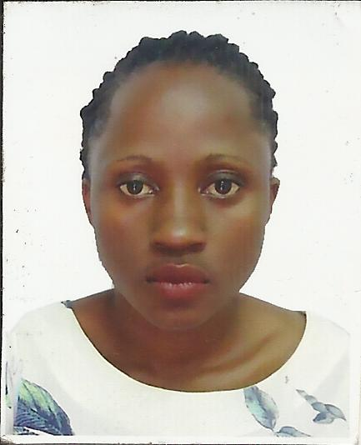
Name: CAROLINE
Gender: FAMALE
Date of birth28/AUGUST/1992
Nationality: UGANDAN
Visa status: VISIT VISA
Languages: ENGLISH AND SWAHILI
Marital status: SINGLE
C/o-Contact number: +971 503718643
Email: caroline.344326@2freemail.com

PERSONAL PROFILE:
I have an experience in the hotel industry working as a waiter in for 5 years in most adorable and prestigious hotels in Uganda. My passion for work has always seen me get promoted to various positions and also getting employment.
CAREER OBJECTIVES:
TO obtain a challenging position in an organization which will enable me utilize my talents,
Creativity, ability to the maximum, contributes to the growth of the organization and by my career as well.

EMPLOYMENT HISTORY / EXPERIENCE
WAITER AT SHERATON HOTEL UGANDA 5* may 2015 to September 2016
Responsibilities
- Welcoming and seating guests.
- Presenting menus and taking orders from guests.
- Serving guests with the right orders in a professional manner.
- Presenting the bills to the guests.
- Ensuring the restaurant is clean at all times
- Ensuring all tables are organized with the right covers.
- Ensuring that you keep unto date with what is in the kitchen and on the menu.
- Ensuring that all conference halls are well organized and kept clean in all the time.

PROTEA HOTEL Kampala, Uganda 4*
WAITER
February, 2014- march 2015

Responsibilities
- Prepare bills and present them to guest at the time of the guest’s departure. Settle all bills on departure
- Ensuring conference halls are clean and equipped with the necessary supplies
- Ensuring that all guests are attended to on time.
- Ensuring that the guest is happy and satisfied all the time.
- Ensuring that the restaurant is clean all the time.
- Ensure that all tables are laid very well with the right covers.
PROTEA HOTEL Kampala, Uganda
Designation: HOSTESS
OCTOBER 2013-JANUARY 2014
- Make sure all menus are wiped down, free of spots or stains, and complete.
- Check with manager to assure there are no large or private parties that are not know about.
- Greets guests, escorts them to their table, pull seat out for the ladies, and present menus.
- Make sure the server is aware they have been sat.
- Keep an eye out that the dining room, entryway, bathrooms, and menus are kept clean throughout operations.
- Attends to guest’s queries / complaints
- Say good-bye to all of the guests. Check to see that everything was wonderful.
MAY 2012-OCTOBER AUGUST 2013
CRESTED CRANE HOTEL, Uganda
WAITER
Responsibilities
- Assisting in various customer functions such as; bringing ordered drinks and eats to the customers.
- Welcoming customers and visitors to the hotel
- Working as a team player in the hotel.
- Crumbing down tables when the customers have gone.
- Looking after the guests in need of refills and others
- Running food in time to avoid red light.
PROFESSIONAL BACKGROUND
2011-2015 BA DEVELOOPMENT STUDIES
CAPABILITIES
• Team player.
• Computer literacy
• micros literate
• excellent communication skills
• Excellent customer service skills.

REFEREES
Available upon request.

