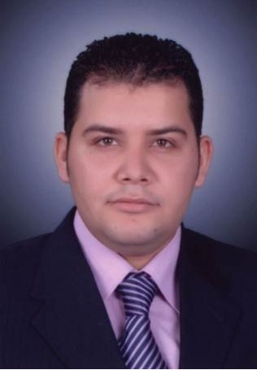

Abdel
Al Nahda Dubai, Dubai
C/o- Phone: +971502360357
E-Mail: abdel.344343@2freemail.com

Professional Summary

Dedicated technical support experienced in network and user support, troubleshooting and software analysis. Technical Customer Service Specialist with the capacity to quickly learn and synthesize new networking technologies.

Skills
- Microsoft Certified IT Professional (MCITP) Certificate | - Customer service expert  - Fast learner  - Skilled multi-tasker  - Working with shifting priorities  - CISCO router & switch management
- Microsoft Certified Professional (MCP)
- Cisco Certified Network Associate (CCNA)
- Network maintenance
- Skilled in TCP/IP and WAN
Work History
01/2014 till now Network & System Administrator
Reload ITS
- Responsible for networking, design, installation and maintenance services.
- Remote administration and management of customer's on-site equipment.
- Manages all network servers and other network components including installation, configuration and maintenance.
- Install, configure, and support an organization's (LAN), (WAN), and Internet connectivity systems.
- Managing, and supporting Domain Controllers, such as (creating users accounts, making and applying Group Policies,….etc.)Using the remote control software tools to provide resolution and diagnosis of faults at remote working locations.
- Managing and maintaining Windows domain infrastructure Active Directory, DNS, DHCP, WSUS, WDS.Windows Server 2008 - 2012
- Monitor network to ensure network availability to all system users and perform necessary maintenance to support network availability.

01/2011 to 12/2013IT Support Specialist
Rowad IT
- Troubleshooting and fixing Network connectivity.
- Fix fault instances for Servers, PCs, laptops and mobiles.
- Troubleshooting and problem solving nature of various faults, demonstrating team working skills by working with others to resolve these and reach logical solution steps.
- Responsible for diagnosing and resolving hardware/software and end user problems.
- First point of contact for all technical queries.
- Allocating work to junior staff and providing induction training to new staff.
- Provided base level IT support to non-technical personnel within the business.
- Installed software, modified and repaired hardware and resolved technical issues.
- Worked closely with team members to meet or exceed all customer service requirements.

01/2009 to 12/2010Technical Support Specialist
Nile OnLine (NOL)
- Install and configure DSL devices in Central Offices such as (DSLAMs – E1 – Routers – Switches)
- Monitoring and report all network.
- Testing new boxes and running different scenarios on test lab.
- Troubleshooting and fixing problems occurred.
- Providing any new ideas that can enhance configuration and make it more dynamic.

Technical Skills
- Installation and Troubleshooting Dell PowerEdge 2850- 2950 –R610- R220.
- Installation and Troubleshooting HP Proliant DL120- DL160I- DL180.
- Configuring Cisco Routers (1700, 2600, 2800, 7600) Cisco Switches (2950, 3500,Nexus 5000).
- Configuring HP & 3Com Switches.
- Installing, Configuring, and Managing Firewall Systems such as :(Sophos – pfSense – MS Forefront)
- Installing, Configuring, and Managing Backup & Restore software (Acronis – CloneZila)
- Installing, Configuring, and Managing VOIP systems such as : (Asterisk – Trixbox - 3CX).
- Installing and Configuring Access points, ADSL-Modems, and Printers.
- Installing and Configuring Monitoring Cameras (CCTV – IPcams) and devices ( DVR-NVR)
- Configuring IP DSLAMs (Alcatal 7300 – Paradyne 8800,8600 – Zyxel - Ccom – Dlink)
- High knowledge about Lucent DSLAMs: Stinger, DSLMax20, and DSL modems.
- Medium knowledge about Huawei IP DSLAM (MA5600, MA5600T, M5603)
- DSU/CSU: Patton, Pardyne.
- Ability to work as Level-1 and Level-2 Technical Support Engineer.
- Designing and implementing different network solutions depending on clients’ environment.

Education
2006 Bachelor of Science, Accounting
Asyut University Egypt

Certifications

- MCITP: Enterprise Administrator on Windows Server®
Certification MCSA: Windows Server® (MCSA)
Certification Cisco CCNA Certified.
Certification Cisco IT Essentials Certificate.
- TOEFL 510

References
All References are available upon request

