Aneeta Aneeta.344354@2freemail.com 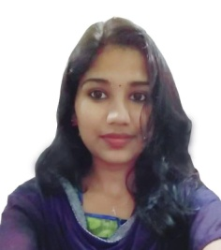

CAREER OBJECTIVE | To pursue an opportunity with a reputed organization, and achieve personal career growth through significant contribution to the organization.
ABOUT ME | I have completed diploma in multimedia animation from loyal college at mananthavady for 2 year at Wayanadu. Currently I am working in National Institute of Business Management at Trivandrum till date. I have skill set in Photoshop, coreldraw, 3ds max, Illustrator, Indesign, and now concentrating in the field of Administration . I have 3 years of experience in this Administration field.
Areas of interest | Operating Systems: Windows 98/2000/XP/7,MS Office  (Word/Excel/Power Point/ Publisher) Corel Draw, , 3ds max, Illustrator, Indesign, and Photoshop etc..
Professional Experience | January 2013 to March 2014  1 year experience in Office Staff , Techno park at Trivandrum.  (Winwrench Software solution Pvt. Ltd)  - Designing brochures , logo and Stationary, Web page Design In photo shop, Corel Draw and Adobe illustrator  - Handling of supplier queries via email and calls, etc  April 2014 to February 2017  Currently working at National Institute Of Management. National Institute of Business Management is a premier online MBA training institute in India rendering Business Administration Courses in Correspondence and Online modes.  - Designing brochures , logo and Stationary  - Supplier management.  - Handling CRM  - Doing admin works and certificate in Photoshop & coreldraw.
Educational qualification | - Higher Secondary (Computer Application) From Kerala University, Kerala (India)  - Diploma in Multimedia Animation  - Practical knowledge of Tally, photo shop, , 3ds max, Illustrator, Indesign, corel draw, and  - Adobe illustrator etc.
PERSONAL DETAILS | - Date of Birth : 21-04-1992  - Nationality : Indian  - Sex :Female  - Marital status : Unmarried  - Languages spoken : English, Hindi, Malayalam,

DECLARATION

I hereby declare that the information furnished above is true to the best of my knowledge and belief.

