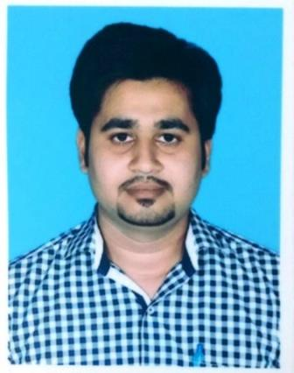
CURRICULUM VITAE

Saifullah

C/o-Cell: +971504973598

Email: saifullah.344360@2freemail.com
CAREER OBJECTIVE:
To join well established organization/firm, contribute my services and prove my worth in good, healthy and challenging environment.
PROFESSIONAL EXPERIENCE:
- Worked as an AccountsAssistant at Master Motor Corporation Private Limited from December, 2015 to July, 2016. My responsibilities were :
- Verify that transactions comply with financial policies and procedures.
- Prepare, verify and process invoices and coding payment documents.
- Data entry for invoices for payment.
- Process backup reports after data entry.
- Manage the weekly cheque run.
- Record all cheques.
- Prepare vendor cheques for mailing.
- List all vendor / Customer cheques in the log book
- Prepare manual cheques as and when required.
- Maintain the general ledger.
- Maintain updated Customer files and file numbers.
- Print and distribute monthly financial reports.
- Preparation of Bank’s reconciliation statement & Coordinate with Head office.
- Preparation of Reconciliation statement for Sales & Recovery, Coordinate with Sales Team & Head office.
- Preparation of Weekly Ageing and Recovery Statement.
- Preparation of Sales & Outstanding Statement for each Customer at the Month End & report to Customers/Head office.
Further Responsibilities
- Report Composing / Writing / Drafting and Formatting.
- Letter Composing / Writing and Formatting
- Keeping Files Record.
- Perform all the Administrator assignments, as and when required.
- Email Corresponding.

- Worked as an Accounts& Admin Assistant at Pakistan Institute of Tourism and Hotel Management from August, 2014 to December, 2015. My responsibilities includes:
  - Prepare Outstanding Fees Record on monthly and weekly basis.
  - Maintaining and updating the Student Records.
  - Preparation of Weekly Ageing and Recovery Statement.
  - Collection of Fees.
  - Data Entry.
- Report Composing/Writing/Drafting and Formatting.
- Letter Composing/Writing and Formatting.
- Keeping File Records.
- Perform all the Administrator assignments, as and when required.
- Email Corresponding.
- Worked with M/S.iSEO Ranker from June 2011 to June 2013 as aData Entry Operator / Computer Operator& Search Engine Optimizer.
  - Data Entry.
  - Letter Composing / Writing and Formatting.
  - Report Composing / Writing / Drafting and Formatting.
  - Email Corresponding.
ACADEMIC QUALIFICATION:
- Bachelor of Commerce (B-Com) fromUniversity of Karachi.
- Intermediate (Science) 2009 from SM Science College.
- Matriculation (Science) from Metropolitan Academy.
OTHER COURSES:
- MCSAONWIRE Technologies.
COMPUTER SKILLS:
Core Competencies:
- Microsoft Excel (Financial Modeling and Advance Excel).
- Microsoft Word.
- Microsoft Power Point.
- Microsoft Access.
- Peachtree.
- Tally.
- Windows Installation.
- Software Installation and Troubleshooting.
- Basic networking skills and Troubleshooting.
- Browsing and E-Mail Drafting.
- Scanning Documents.
PERSONAL DETAILS:
Date of Birth : December 19th, 1990
Religion : Islam
Nationality : Pakistani
Marital Status : Single
Iqama Status : Transferrable Iqama
REFERENCES:
Can be furnished on request.

