MURUGESAN QA/QC ENGINEER / INSPECTOR Nearly 12 years of experience
( 2 years 3 month in UAE & 2 years in Oman )
Effective leader with excellent skills in supervising engineers thus controlling conformity to sustain growth momentum
Possess sound knowledge in preparing and reviewing process documentation
murugesan.344385@2freemail.com

Key Skills  QMS Lead Auditor – ISO 9001- 2015  Quality Assurance / Control  Process Improvements  Liaison & Coordination  Internal Audit  Material Management  Documentation & Reporting  Quality Management System  Team Management |  | Profile Summary  - Expertise in working as per quality objectives in compliance with the project requirements & taking necessary control measures to minimize any deviations/rework and resolving those  - Outstanding in networking with Consultants, Suppliers, Sub-Contractors, Vendors, and Supervisors, etc. for resolving various quality related issues contractually  - Certified Quality Control Engineer by Petroleum deployment of Oman (PDO)  - Insightful experience in conducting internal company audits and sub-contractor audits & reviews for ensuring strict adherence to the process parameters/systems as per defined guidelines  - An enterprising leader with skills in leading personnel towards accomplishment of common goals  - Coordinating for site testing or third party testing for various activity as per projects requirement  - Preparing, maintaining & ensuring all quality control documents and logs compiled are as per the project requirement and within timeframe  Prepare & review the Technical Submittals, ITP MS, RFI, CVI, NCR,  - 8 years track record of work experience in PMC / EPC organizations
Career Timeline
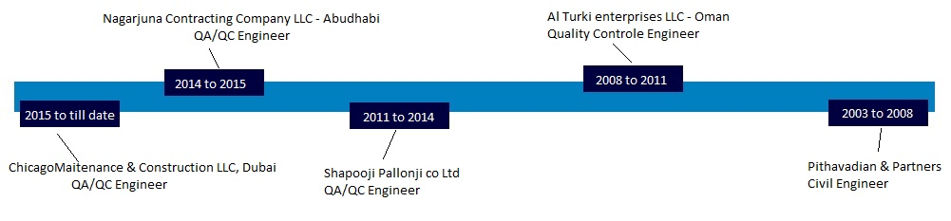
Soft Skills |  | Education  - Diploma in Civil Engineering from Government Polytechnic College with 90% in 2003  - B tech civil Pursing  - 12th from Ramakrishna Hr Sec School, Tamil Nadu
- Work Experience in UAE
Since April’16 with Chicago maintenance and construction LLC, Dubai as QA/ QC Engineer
Client : GEMS International Schools
Designer : CPG Consultants Private ltd Consultant : MEECON & NEB
Projects: Gems founder school, Gems National school for Boys & Gems National School for Girls Construction of school buildings - build up area 64000 Sqm fast track project complete in 8 month. ( Experienced in excavation, concrete works, precast wall, hollow core slab, drywall partition, block work, plastering, painting, GRC panels, structural steel canopy, roof water proof, tiling, carpet, vinyl, paver blocks, roads, underground drainage, storm water, handrails football , volleyball, indoor sports courts, swimming pools, fences, shades and other finishing works, etc)
Key Result Areas:
- Manage overall quality control of Construction Contractors output in terms of ITPs in liaison with inspectors
- Involvement where required in Work Inspections, Material Inspections, Mockup Inspections and perform Factory Visits
- Co-facilitating with different departments such as Mechanical, Electrical, Instrumentation and Civil
- Supervising the site by daily visits & monitoring quality related activity on the project
- Verifying & monitoring subcontractor activity and issuing Non-Conformity reports if required
- Review and assess contractors’ and sub contractors’ pre-qualifications, inspect their showrooms, workshop/factory as and when required
- Reviewing and verifying all incoming material as per approved material submittal/project requirement including site subcontractor's material and raising material inspection request for consultant approval
- Facilitating verification, sampling and control procedures for Ready Mix Concrete supplies at site
- Contribute to preparing ITP, method statement, work instructions
- Carry out internal Audits, prepare summary of audit.
- Coordinate for site testing or third party testing for various activity as per projects requirement
- Preparing, maintaining & ensuring all quality control documents and logs as per the project requirement, within timeframe
- Work in liaison with Employers QA/QC manager to close procedural NCRs issued to the project by the Employer
- Prepare handover checklist & collect, review, submit handing over document from subcontractor & contactors to the consultant.
- Coordinate with site team to close the snag list issued by client/consultant.
Oct’14 to March 2015 with Nagarjuna Contracting Company LLC, Abu Dhabi as QA/ QC Engineer
Client : Abu Dhabi Vocational Eduction and training Institute ( ADVETI)
Main Contractors : Z General contracting LLC
Designer : WME Engineering consultancy LLC
Consultant : Elite Design Engineering Consultancy & architects LLC
Projects : Secondary Technical School – Al Ain Abu Dhabi
Project Scope : A commercial mixed project – Construction of school buildings consisting of 6 blocks including administration building with library, cafeteria, two workshops, MEP building, football court, tennis ball & volley ball court, Irrigation system, soft & hard landscaping, Stormwater pipeline
From July’11 to September’14 with Shapoorji & Pallonji Co. Ltd., Chennai, India as QA/QC Engineer
Client : DLF Homes Private Ltd Consultant : Colliers international Consultancy
Projects : Infrastructure development for DLF Garden City – Chennai
Project Scope: Construction of multistoried buildings in Solinganallur Chennai which consist of 20 towers of 19 floors each with two underground basements for each tower.
Previous Work Experience in Gulf
From October 2008 to Feb’11 with Al Turki Enterprises LLC – Oil & Gas Division, Oman as Quality Control Engineer - Approved by PDO of Oman
Client : Petroleum Development of Oman
Consultant : Velosi Consultancy
Project:
(A)GRE Pipe Line at Nimr 33 KM with OHL Line, Laying of Cross country GRE pipeline of 33 KM on pot, Construction of OHL line and allied works, Construction of Oil & Water analyzer, SRV panel shed foundation, Control room & Switchgear room, Pipe supports, pipe rack foundation, Value pit, Installation of Fence & Gates.
(B)66/11 KV GIS Substation, 40 MVA & 1000 KV Transformer foundation, Cable trench, Duct banks, box culvert, pump room, fire & ground water tank, oil containment tank, asphalt road work, guard room, sewage pipeline works, deluge trench systems including boundary wall
From Oct’03-Aug’08 with Pithavadian & Partners Architects, Chennai – India as Site Engineer
Project-1: Construction of residential buildings
Certificate Attestation
- Embassy of the sultanate of Oman & Ministry of External Affairs – India
Trainings
- QMS Lead Auditor – ISO 9001 – 2015 ( IRCA Approved )
- CMQ/OE – pursuing
- Three days awareness training programme on Quality Management System ISO 9001:2008 by DNV Business Assurance
- Project Management Professional (PMP) internal Training programme
IT Skills
- Operating System Windows, MS Office Excel, PowerPoint, Auto CAD
Personal Details
Date of Birth & Age : 27thJuly 1982 & 34
Nationality : Indian
Marital Status : Married
Language Known : Tamil, English, Hindi, Malayalam

