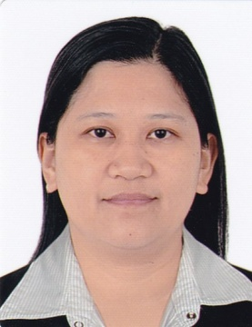
Margarita
C/o-Mobile No. : +971505891826
E-mail: margarita.344393@2freemail.com

Objective:
Extensive experience in operation.Passionate about quality and customer satisfaction. I offer my service and determination to be an asset to the company throughout the duration of my work.

Educational Attainment:
1995-1996 Systems Technology Institute(STI)Lipa,Batangas
Programmer
1991-1994 Lyceum of Batangas
Computer Science

Work Experience:
April 17, 2013 – April 12,2016 Front Desk Receptionist/Secretary
Production Department
Advanced Semiconductor Engineering Inc.(ASE)
Kaifa Road, N.E.P.Z., Kaohsiung City, Taiwan R.O.C.

Nov. 17, 2009 – Nov. 4, 2012 Adhesive/Heat Spreader Operator /Material Handler
Advanced Semiconductor Engineering Inc.(ASE)
Kaifa Road, N.E.P.Z., Kaohsiung City, Taiwan R.O.C.

Sept. 11, 2006 - Aug. 23, 2009 Adhesive/Heat Spreader Operator
Advanced Semiconductor Engineering Inc.(ASE)
Kaifa Road, N.E.P.Z., Kaohsiung City, Taiwan R.O.C.

July 27, 2003 – July 17, 2006 underfill/Adhesive/Heat Spreader Operator
Advanced Semiconductor Engineering Inc.(ASE)
Kaifa Road, N.E.P.Z.,Kaohsiung City, Taiwan R.O.C.

2001 – 2002 Distributor/Networking Company
Forever Living Products

1995 – 1996 Office Clerk/ Hardware & Software Company
Micro Exchange Corporation

Job Description: Front Desk Receptionist/Secretary

- answer telephone, screen and direct calls
- take and relay messages
- provide information to callers
- greet persons entering organization
- deal with queries from the public and customers
- ensures knowledge of staff movements in and out of organization
- general administrative and clerical support
- prepare letters and documents i.e. courier, etc.
- receive and sort mails and deliveries
- schedule appointments
- maintain appointment diary either manually or electronically
- organize meetings
- tidy and maintain the reception area
- maintain office stationeries and consumables

Job Description:Machine Operator/Material Handler
- Finding materials on the shelves and putting them on machines.
- Push materials if there is Hot Lot.
- Monitor machine operations to detect malfunctions; report or resolve problems.
- Clear minor error

Skills and Ability:
- Ability to organize resources, to work with others, to learn a variety of technologies as well as the ability to acquire knowledge.

