Elgizawy | Email: eligazawy.344398@2freemail.com  Location: ELREGGA, DUBAI UAE  VISA Status: tourism visa  Marital status: single  Date of birth:07/09/1991  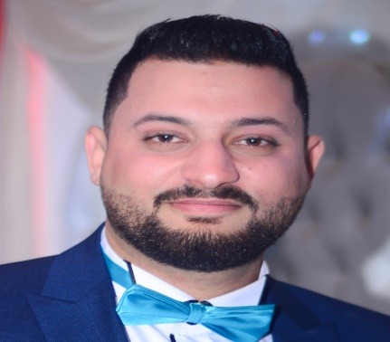
Travel Consultant

Personal Summary:
High Education, Graduated from faculty of tourism and hotels, Courteous, excellent organizational skills and highly efficient with a unique understanding of the travel industry. An experienced travel consultant who is able to make the best possible travel arrangements for a client’s destination, mode of transport and travel dates. Highly motivated, target driven and with exceptional multitasking skills along with an ability to produce tailor-make itineraries for travel to short or long haul destinations.

Objective:
I am seeking a position in the travel industry focusing on sales, customer care and office management. I am a dedicated team leader who wants to use his skills and knowledge to help my team to achieve using both traditional and modern approaches.

Areas of Expertise:
Services | - Travel industry knowledge  - Selling techniques and Product knowledge  - Online reservations and Customer service  - Arranging flights, insurance and accommodation  - Using a booking system to secure reservations as per customer’s requirement  - Collecting and processing payments as per company policy  - Advising clients on travel arrangements, e.g. visas and passports  - Keeping clients up to date with any changes of schedule  - Dealing with complaints and refunds
Personal | - Willing to work on a shift basis including evenings and weekends.  - Always smartly dressed, articulate and presentable.  - Ability to take ownership of issues and to work alone with little or no supervision.  - Extremely organized with a high level of attention to detail.  - Ability to respond to timeframes and deadlines with pace.
Global Distribution System: (Reservation Systems)
Amadeus | - Basic Core Course  - Fare Pricing, Ticketing, Refunds, Reissuance and EMDs  - Advance Ticketing Course
Sabre | - Basic Core Course  - Maintaining Queues  - Fare Pricing, Ticketing, Refunds, Reissuance and EMDs
Galileo | - Basic Core Course and Refresher  - Fare Pricing (Fare Shopper)  - Queues checking for confirmation and cancellation deadline
Hotel Bookings & Leisure: (Reservation Systems)

Local Vendors | - Hotel reservation and Waitlist confirmation  - Organizing group tour packages  - Activities while on locations and meal arrangements as per requirements  - Arranging VIP service for departure and arrivals  - Local Guide arrangement with multi language

Career History
Travel and tourism specialist at Fursan Travel & Tourism Riyadh, KSA | 23rd July 2014 | 30th December 2016
Fursan Travel has numerous government departments to deliver travel amenities. I’m providing an efficient, courteous, and responsive travel booking service to Royal Saudi Air Defense Forces Riyadh. Offering my services to suit clients and ensuring that all administrative terms and conditions of contracts are adhered.

Link: www.fursan.com.sa | Contact: 920-000-442 | Address: Riyadh - King Fahad Road

Travel Consultant at travelers Egypt in( Sharm Elshaikh- Egypt) | 05th march 2013 | 29th June 2014
Travelers Egypt is one of biggest companies in tourism industry in Egypt and it has numerous branches in Egypt besides hotels and transportation I was a team leader of sharm elshaikh branch where it was new office during this time and I was chosen to be first employee there.

Link: www. travellers-group.com/Travellers_Egypt.html | Contact: +202 2792 0081 fax:+202 27964104 | Address: 2,Dar Elshefa st. Garden City, Cairo, Egypt.

Travel Consultant at Elkamar travel Shebeen Elkom ,menofya,Egypt. | 20th September 2012 | 30th February 2013
Elkamar travel was my first experience in tourism field and where I gained a lot of experience, they employed me after I graduated from faculty of tourism and hotels and I was suitable for their work as a travel consultant .and took place among a lot of skilled employees to work hardly and to learn more about our great industry.
Link: http://www.elkamartravel.com/.net | Contact: +2 048 2332 109, +2 0482332 108 | Address: 5 Anwar Elsadat,Shebeen Elkom ,menofya ,Egypt.

- Education:
*BA: Bachelor of Tourism and Hotels, 2012,Menofya University very good Degree.

