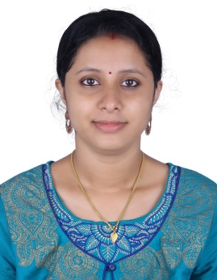
SOWJA
SOWJA.344444@2freemail.com

objective

Seeking for substantial responsibility where my past and varied experience would be fully utilized in a career opportunity and where making a significant contribution to the success of my employer which will gain me a career advancement opportunity.

Personal Details

Date of Birth : 07/08/1992
Nationality : India
Gender : Female
Religion : Hindu
Marital Status : Married
Language Known : English, Hindi, Tamil & Malayalam
Visa Status : Husband Visa

EDUCATIONAL QUALIFICATION

- B.A Literature from Annamalai University, Tamilnadu.

- Diploma in Aviation, Travel &Hospitality from Frank finn Institute Thrissur.

computer QUALIFICATION

- Knowledge in Windows, MS Office, Galileo etc.

Page -1

work experience

- 2 ½ Years Customer Relationship & insurance experience in Badr Al Samaa Medical Center Bur Dubai, UAE
- Worked as a Customer Relationship Officer in TATA AIG Life Insurance Company ,Thrissur Kerala, for 5 Months.

duties and responsibilities

- To take approvals(online&verbal) from the Insurance companies.
- To maintain medical records and report statistics when required.
- To register /Billing patients according to hospital protocols.
- Assigned the responsibilities of handling outbound and inbound calls.
- To explain clinic policy to patients while receiving and delivering messages.
- To assist patients in accurately completing appropriate forms and documents for the required information’s.
- Collect the detail about the customer.
- Inform the customer about the billing date and due date.
key skills

- Extremely inspired and committed person with proven analyzing and analytical skill sets.
- Well organized and result oriented individual with a clear vision towards completing the assigned task in a timely and effective manner.
- Young energetic and self-motivated.
- Ability to reach targets with in deadlines in an intensely competitive filed.
- Strong desire to do challenging works , efficient worker and quick learner.

- Smart Working , Punctual & Optimistic
- Good Learning & Listening Abilities
- Committed to providing excellent quality service.
- Willing to go out of my way to make guests comfortable.
- Results-oriented, self-starter with experience

declaration
- I certify that all the details provided above are all correct according to my knowledge and belief.

