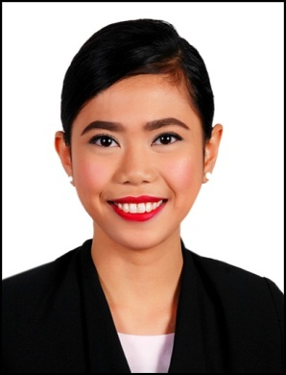
ANGELICA
C/o-+971503718643
angelica.344453@2freemail.com

EDUCATIONAL BACKGROUND:
Bachelor of Science in Hotel and Restaurant Management
Rizal Technological University, Philippines
SY 2010-2014

WORK EXPERIENCE:

Guest Relations Associate | July 2014 – November 2016

Discovery Shores Boracay (The Discovery Leisure Company Inc.)
Duties and Responsibilities
- Works as a team leader and designate tasks to the other guest relations associate.
- Meets and greet guests as they arrive and bids them farewell as they leave.
- Assist them to their room and provides an informative tour of the property at the same time.
- Assist guests in the check-in process and Inputs information to the system (Hotel Information System).
- Handling guests arrivals and departures requests and inquires.
- Initiates room up sell opportunities and helps colleagues in closing up sell deals.
- Prepares a list of VIPs and Long staying guests and assigns them to other Guest Relations Associates for close monitoring.
- Plans, arranges and hosts events for long staying guests as an additional perk for staying a certain number of nights.
- Checks on guests’ over-all experience and prepares Daily Interaction Reports.
- Does the room set-up for the next day’s arrival including arrival letters, cards, banners and kits.
- Handles ocular inspections for travels agents and FITs.

F&B Attendant | January 2014 – June 2014

Sofitel Philippine Plaza

Duties and Responsibilities
- Looks after the necessary preparations before the start of operation.
- Handling reservations, welcoming and seating guests.
- Managed cash register and monetary transactions correctly.
- Does suggestive selling, takes order and serve food and beverages.
- Attends to guests’ inquiries, requests and complaints.

ON-THE-JOB TRAININGS:
Sofitel Philippine Plaza | Sofitel Luxury Hotels
720 Hours | October 24 –February 2014
- Hotel Practicum

- Restaurant Practicum
Crustasia Rockwell | The Red Crab Group of Restaurants
200 Hours | June 14 – July 24, 2013
Discovery Shores Boracay | The Discovery Leisure Company
360 Hours | April 22 – May 25, 2013

TRAININGS ATTENDED:
National Competencies (NC) from TESDA
Baking and Pastry NCII  Certificate No. 12130502022315  436 Hours | Mandaluyong Manpower Development Center for TESDA  June 13, 2012
Front Office Services NC II  Certificate No. 12130502018912  436 Hours | Gateways Institute of Science and Technology for TESDA  May 28, 2012
Bartending NC II  Cert. No. 10130702027801  336 Hours | AsianTouch International Institute for  TESDA  December 31, 2011

PERSONAL INFORMATION:

Date of Birth : September 9, 1992
Place of Birth : Manila
Civil Status : Single
Citizenship : Filipino
Height : 5’ 2”
Weight : 110 lbs.
Languages Spoken : English, Mandarin (conversational), Tagalog
Other Skills : Computer literate (Microsoft Office) and Hosting
Visa Status : Visit

REFERENCES:
- Available upon request

