RAHMAN  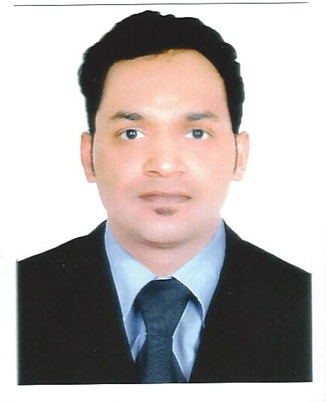  E- mail:  Rahman.344475@2freemail.com  C/o-Contact No:  +971 503718643  Language Known :  - English  - Hindi  - Malayalam  - Arabic | CAREER OBJECTIVE  A creative and enthusiastic person with a diverse range of administrative /clerical experience. Outgoing with strong and effective organizational and communicating skills. Highly motivated with problem solving skills. Aim to obtain a challenging position that would attain the maximum goal and to make effective use of my professionalism and educational background for continuous career improvement.  PRIMARY ASSETS  - Positive outlook and open minded approach.  - Flexibility, Hardworking and a good time keeper.  - Sincere, loyal and dedicated to job.  - Motivated team player and maintaining good relationship with the people.  - Good reader and listener.  - Understands the importance of integrity within the work place.  PROFESSIONAL PROFILE  - CUSTOMER SERVICE AGENT, UPS Gulf LLC, UAE (Dec 2013 –sep 2015 )  - SENIOR SALES ASSOCIATE AT H&M (M.H. ALSHAYA GROUP ) Dubai, U.A.E (2 Years )  PROFESSIONAL EXPERIENCE  CUSTOMER SERVICE AGENT, ( UPS Gulf LLC, UAE)  (Dec 2013 –Sept 2015 )  - Organize export, domestic, Import and Cheque collections and ensure the collection has been done properly.  - Arrange the Short collections from the cash customers and assist accounts team to collect the Pending UPS overdue invoices.  - Deal with walk in customers and collect precise amount of cash by issuing the receipt. Make Sure the receipt has been sent to the accounts team in the timely manner.  - Track the shipment and advise the customers accordingly. If any issues, escalation will be done to the concern department to resolve at the earliest.  - Advise the customers about the scheduled delivery date, customs duty and delivery address of the export and import shipments.  - Ensure to call back abandoned calls 100%.  - Providing third party rates to the customers with accuracy.  - Replying customer enquiries promptly.  - Inform the customers proactively if any delays with the export shipment especially Saudi Arabia shipments.  - Providing the quality information to the customers from WorldCom.  SENIOR SALES ASSOCIATE AT H&M DUBAI, U.A.E  - Dealing with a wide range of customer service, supervising and managing the activity in the store.  - Provided a high customer satisfaction, ensuring that both internal and external customers received a quick response to their enquiries, the right size and color matching outfits.  - Assisted customers in the shop to choose products that were appropriate to their needs  - Provides historical records by maintaining records on area and customer sales.  - Contributes to team effort by accomplishing related results as needed.  - Resolves customer complaints by investigating problems developing solutions making recommendations to management.  - Submits orders by referring to price lists and product literature.  - Focuses sales efforts by studying existing and potential volume of dealer.  - Adjusts content of sales presentations by studying the type of sales outlet or trade factor.  SKILLS  - Extensive Knowledge in MS Word and MS Excel  - Good Knowledge in handling and re-solving customer complaints.  - Personal Skills: Adaptable, Broad-Minded, Competent, Dedicated, Reliable and Optimistic.  - A good team player and Ability to plan jobs and avid for knowledge  - Consummate task with self-driven and dynamic responsibilities  - Handle details, Coordinate tasks, Set goals and meet deadlines  - Excellent Communication skills and Management skills.  PERSONAL STRENGTH  - Good understanding ability.  - Well prepared to adapt to difficult situations.  - Project coordination and able to work well with all levels of management and staff.  - Excellent communication skills.  ACADEMIC PROFILE  - Completed Bachelor Of Business Administration ( BBA)  - Complete Secondary High School By Certificate.  - Attended Introduction to IT & Basic Application and Computer Networking.  - Attended Small Business Management and Business Growth Strategy.  PERSONAL DETAILS  Date of birth : 10/01/1989  Marital Status : Married  Nationality : Indian  Driving License : UAE  DECLARATION  I hereby declare the above shared information is true my knowledge an belief.  Thanking you for your time.  RAHMAN

