CURRICULUM VITAE
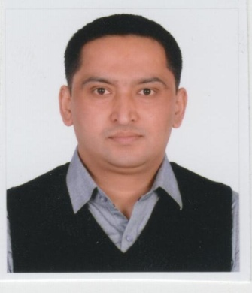
Personal Details:

Name : Uttam
Date of Birth : 28th March 1980
C/o-Contact : +971505891826
E-mail :- uttam.344490@2freemail.com
Marital Status : Married

Education:

2015 Master’s Degree in Anthropology.
Patan Multiple Campus, Patan, Lalitpur, Nepal

2008-2009 Diploma in Hospitality & Tourism Management.
Inter Napa College,Sotira, Cyprus.
(I have completed only up to Third out of Six Semester)

2006 Bachelor’s Degree in Business Studies.
Baneshwor Campus (TU),Shantinagar, Kathmandu, Nepal

1999 Proficiency Certificate Level.
Nepal Commerce Campus (T.U.), Minbhawan, Kathmandu, Nepal

1997 School Leaving Certificate.
BalkumariSecondary Boarding School,Naxal, Kathmandu, Nepal.

Work Experience:
2016 –Present Cheers Enterprise Pvt. Ltd., Kamaladi, Kathmandu, Nepal.
Asst. Administration Manager
[Job Description (JD):-Supervise Staffs , their Attendance, leave management, Maintain Vehicle Log book, Fulfill various government related task, Supervise Repair and Maintenance, Involvement in purchase process, Stationery management etc.]

2013 – 2015 Tribhuvan International Airport, Kathmandua, Nepal.
Computer Operator (Freelancer)
[JD: - Receipt and Journal Voucher entry in MiDas Accounting Software, Filling Voucher in properly. Letter typing in English and Nepali Languages, Making files of various parties and airlines to keep their important documents etc.]

2012 – 2013 Civil Estates Pvt. Ltd., CTC Mall, Sundhara, Kathmandu, Nepal.
Jr. Asst. Operation Manager
[JD:-Supervise Staffs, their Attendance, leave management, Maintain Vehicle Log book, Fulfill various government related task, Supervise Repair and Maintenance, Cleaning , Parking area of Shopping Mall Involvement in purchase process, Stationery management, Supervise Security Guards, Work as a Liaison officer between Mall and Tenant or Shopping units holder, Handle their grievances, Prepare Report of Mall status to Steering committee of the Mall, Assist to Sr. Operation Manager for different administrative worksetc.]

2010 - 2011 Aayusha Developers Pvt.Ltd., Shantinagar, Kathmandu, Nepal.
Sr. Asst.Accountant.
[JD: - Maintain party ledger, Entry in Tally Accounting Software, Print and filing those entries, Involvement in Bank deposit, collection, Assist to Head Accountant for different accounting tasks etc.]

2008 - 2009 Lived in Cyprus as a Student.

2003 - 2005 Supreme Overseas P. Ltd.,Koteshwor, Kathmandu, Nepal.
Head of Administrative Assistant.
[JD: - Prepare document for Embassy Submission on behalf of Job seeker, Prepare document for Department of Labor, Check emails of parties and respond as per senior’s order, Typing letters both in Nepali and English, Assist Head accountant for different kind of accounting works, Involvement in Bank deposit, collection etc.]

Skills:
- Able to handle overall operational and administrative works of office
- Excellent knowledge in Computer’s program MS-Office Package and Internet,
- Good typing speed in English and Nepali,
- Operate Accounting Software ( Tally + Midas),
- Maintain Manual Accounting Work,
- Able to correspond in Nepali, English and Hindi.

Training:

2000 Certificate in Basic Computer Applications -98. Nepal Computer Institute P.Ltd.,Bagbazar, Kathmandu, Nepal.

