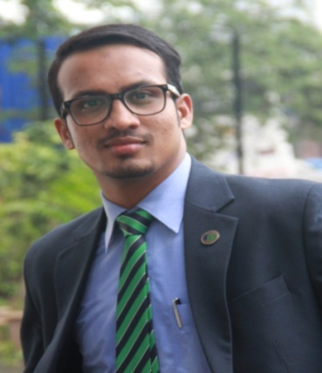
Abrar

C/o-Mobile no: +971505891826

Email id: parkar.344511@2freemail.com
DOB: 21st August 1992

Quote Of Life : “Be like a diamond which is precious and rare, don’t be like stones which are found everywhere!

Career objective: To carve out a platform for myself in the corporate world aligned to the marketing/sales department in an organization wherein I can prove my abilities and talent contributing towards the organizational and personal growth in parallel. With entrepreneurial instinct always willing to take high level initiates and can do multi-tasking.

Education
Year | Degree | Institution | Percentage/Marks
2016 | MBA(Marketing) | Kohinoor Business School, | A Grade
 |  | Mumbai
2013 | B.com | NKTT, Mumbai | 80.14%
2010 | Class 12th | IES, University | 78.50%
2008 | Class 10th | IES, pune | 78.30%

Academic Recognition & Achievements

• Awarded with the title of ‘Best student of the college’ for two consecutive years (during graduation)

• Have won many prizes at intercollegiate competitions in elocution, debate, singing, dancing, acting, drawing, etc

• Volunteered The BMA awards wherein many top notch personalities of banking, ecommerce and FMCG industry were the members of the panel.

• Awarded with the prize for best academic performance during HSC.

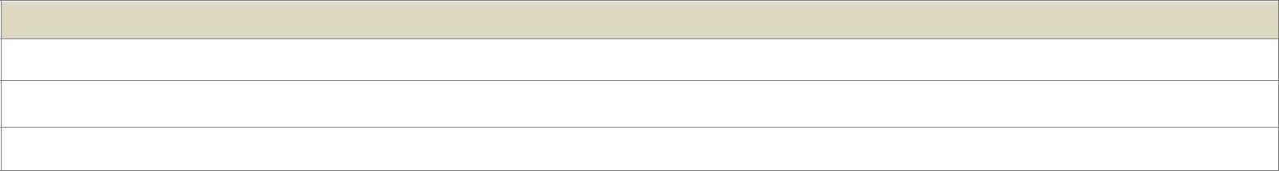
Summer Internship - Medikabazaar.com, Mumbai, Date(1st May-to 31stJuly)

Project Title: study of customer management cycle

Learnings: The comparative study helped me devise strategies for customer acquisition for 1 start-up.

Conclusion: Understanding the customer from the grass root level is essential for survival of any business.

Industry immersion project-“Study of E-commerce (online retail) industry in India”.

The project helped me understand the ecommerce business focused to online retail in the country. Studied the several facets of the online retail business by understanding the business models of ecommerce giants

Evaluating several factors that drive the growth of the e-tail sector and conclusion that Omni channel being the strategy to survive in the cutthroat competition in the country’s retail space.

Work experience
Territory manager-@ Coffee Day Global (Working)
- My KRA’s comprise of B2B/Institutional sales of Vending machines. This involves acquisition of new business via several sources viz; area mapping, feet on street, meetings etc. And also retaining existing client base by ensuring efficient & timely services being provided.
- Also I take care of Channel management by handling big time distributors ensuring free flow of business.
- Partnering and nurturing right set of channel partners helps me focus on the core business activities and maintain the company’s value preposition intact.
- Client retention also becomes an essential part. Timely visits to existing clients and taking feedback become an essential aspect of my profile.

Corporate Sales Manager @ Box8 :Poncho Hospitality Pvt Ltd (Dec 2015-Dec 2016)

- At Box8 I was handling entire Sales revenue cycle by approaching companies and understanding their needs in terms of food and accordingly undergoing Corporate Tie-up helping me to build relationships and get bulk orders
- The role also gave me holistic approach of business as I lead a team of 13 employees under me and handle the operations and marketing of two corporate dine in outlets of the company by driving better sales growth and improvising service delivery through sound people management.
- Ensured better Training and development of the team in order to help them get well acquainted with the work atmosphere and grow in the organizational hierarchy.

Accounts Executive: Tata Projects Limited (May 2013-March 2014):

- Here I was responsible for booking the bills in the system and maintaining proper track record of the vendor’s payment.
- Timely disbursement of vendor’s outstanding amount and several other aspects related to disbursements were taken care by me.

Extracurricular Activities
- Singing enthusiast - participated in singing competition in various cultural events including theCollege Fest in Feb’15.

- Member of the cultural committee, a student driven club that plans and conducts various cultural programmes in the college.

- Successfully organized cultural events, competitions including the Cultural Fest in Feb’15 at KBS

- Had been Joint secretary of the college during graduation.

Computer Skills
- Basics - MS Office XP (Word, Excel, PowerPoint).

- Windows Server 2007/2008/Windows XP. Windows Vista. Windows 7

Personal details:

- Hobbies : Interacting with people, Reading, singing, acting, cooking and playing cricket.

