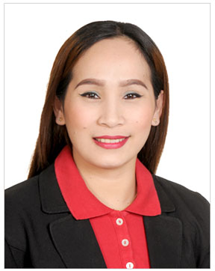

**RELEVANT EXPERIENCES**

**Waitress/Cashier**

**Cafe Ceramique**

**Jumierah Town Center, Dubai**

**January 13,2015- January 13, 2017**

Duties and Responsibilities:

* Greet the costumers/guests as they arrive.
* Present menus to the costumers and answers thier questions.
* Make recommendations and try to upsell.
* Take orders.
* Serve the ordered food and ensure that costumers are enjoying thier meals.
* Collect payments from costumers..
* Maintain the cleanliness and orderliness of the shop,(Tables, chairs, counter, washroom, etc.)
* Answer the phone to take table reservation and birthday party reservation and explain how it works.
* Punch the order to the POS machine with the correct information of the Costumers.
* Coordinate with the manages, supervisors, and staff to ensure smooth

Operation.

* Promptly respond to the costumers queries and additional orders/requests.

**Beauty Advisor/Consultant**

**Ever Bilena Cosmetics Inc.**

**SM Megamall, Cagayan de oro city, Philippines**

**October 7,2013-October 10, 2014**

Duties and Responsibilities:

* Promote and sell products of the company to costumers who walk-in.
* Extend extensive beauty product knowledge to costumers.
* Attend and respond to costumers queries on beauty products to enhance sales.
* Meet and maximize sales target and established goals.
* Prepare reports on returned and / or damage beauty product.
* Offer extensive beauty and cosmetics information to costumers and assist them in choosing right products.
* Maintain appearance , inventories and reports of the department.
* Create affective displays to sell seasonal and promotional beauty products.
* Maintain clean work areas and ensure adequate at the staffing is done.

**: C/o- +971-503718643**

**:maricel.344552@2freemail.com**

**:Al Mankhool, Dubai, UAE**

**SKILLS AND STRENGHT’S:**

Customer Service Oriented.

Pro Active and work as a team player.

Hardworking and be able to work independently.

Extreme organized, efficient and responsible.

Willing to learn new skills, flexible and reliable.

Resourceful, honest and trustworthy.

**EDUCATION:**

**Bachelor of Science in Hotel and Restaurant Management**

Cagayan de Oro College- Phinma

June 2005 -March 2006

1st year level

**PERSONAL INFORMATION:  
Nationality:** Filipino **Date of Birth:** March 06, 1986 **Visa Status:** Visit Visa

**SUMMARY OF QUALIFICATION:**

Have 2 years experienced as cashier and waitress in food and beverage industry.

Have 1 year experienced in promoting products, Beauty Advisor/Consultant in retail sales industry.

Have demonstrated poise and confidence in presenting and speaking with costumer.

Have established good relationship with colleagues.

**CERTIFICATION AND AWARDS:**

**Employee of the Month**

Cafe Ceramique-May 2015

**Best Employee and Best Attendance**

Cafe Ceramique-October 2015

**Employee of the year**

Cafe Ceramique-2015

To be able to work with a company that will improve my skills and knowledge that I have gained from my previous experience for the improvement of the company business.

**Maricel**