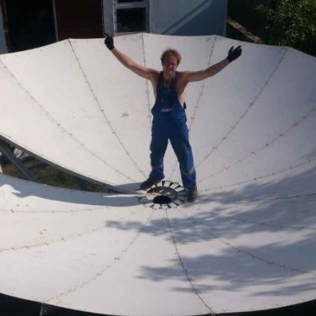
Vitaliy
Vitaliy.344574@2freemail.com

Projects

At 2014 year ASTEL JSC decided move to new site. I was planning antenna field, and control of building new satellite communication ground site. ( Control and coordinated operations of installation teams)

Professional Experience
Head of sector satellite technology
ASTEL JSC
April 2015 – Present (1 year 9 months), Astana, Kazakhstan
* Coordinated operations of installation teams
* Leaded management work of sector satellite technology.
* Planning and building new satellite communication ground site of ASTEL JSC
--------------------------------------------
Satellite telecommunications engineer
ASTEL JSC
November 2013 – April 2015 (1 year 6 months), Astana, Kazakhstan
* Satellite telecommunication equipment maintenance and implementation (equipment:VSAT, SE, SE II, SCPC, Paradise, Anacom, Wavestream, NJT).
* Installation and configuration of C and Ku TX/RX antennas of satellite communication earth stations (1.8 m to 5.6 m)
* Able to install, maintain, operate, and solve troubles with above mentioned satellite systems.
* Familiar with data protocols, access devices and transport mechanisms.
* Had hands on experience on link analyses, and ground telecommunication systems implementation.
* Experienced with the Government and Military relevant projects and processes, including joined the civilian and military sectors.
* Trained clients to the use the company equipment (portable satellite communication complex, TracStar systems)
Equipment Usage Experience:
- BER Testers (RAD HBT, Sunrise Telecom MTT)
- Spectrum Analyzers ( Rohde & Schwarz, Agilent ESA)
--------------------------------------------
RF Spectrum Management & Monitoring Engineer
Republican center of space communication
May 2012 – July 2013 (1 year 3 months)Astana
* Monitoring frequency resource of satellite "KazSat-2".
* The regular measurements and monitoring the technical parameters of frequency, modulation depth, occupied RF bandwidth, power flux density, offset, emission type etc to ensure compliance of technical parameters.
* Rationalization and optimization the usage of the RF spectrum, to avoid Interference problems.
Equipment usage experience (Thales Alenia Space):
- eCSM (Communication System Monitoring)
- ESVA (Earth Station Verification and Assistance)
- TCA (Telecom Carrier analyser)
- Agilent PSA (Performance Signal Analyzer)
--------------------------------------------
Satellite telecommunications engineer
ASTEL JSC
July 2009 – May 2012 (2 years 11 months)Astana
* Satellite telecommunication equipment maintenance and implementation.
* Installation and configuration of C and Ku TX/RX antennas of satellite communication earth stations (1.8 m to 3.7 m)
* Able to install, maintain, operate, and solve troubles with above mentioned satellite systems.
--------------------------------------------
Maintenance telecommunications engineer
ALTEL JSC
May 2008 – February 2009 (10 months)Astana
Implementation, Operation and maintenance of Ericsson CDMA Base Transceiver Stations (BTS) and Base Stations (RBS), Radio Microwave stations.
Worked with WAN (Wide area network)
Implementation, operations and maintenance of Digital Multiplexers with PDH and SDH principles, etc.

Education

School: Siberian State University of Telecommunications and Information Sciences, Novosibirsk, Russian Federation
- Highest Degree: Master's Degree
- Education Period: 2007/09-2008/08
- Major: Audio visual technology master’s degree

- Highest Degree: Bachelor Degree
- Education Period: 2003/09-2007/08
- Major: Bachelor of Engineering and Technology of Radio Engineering

Languages
- Mother Tongue: Russian
- Chinese Level: Newbie
- English Level: Intermediate

Skills & Endorsements
Telecommunications, VSAT, RF, Integration, Wireless, Satellite, Project Management

Interests
Travel, fishing, playing guitar, skiing

References Available Upon Request

