Ibrahim

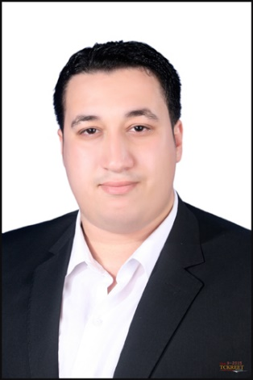

Nationality: Egyptian
Military status: Exempted
DateofBirth: 1991.12.25
E-mail: ibrahim.344579@2freemail.com
C/o-Phone: +971505891826

O B J E C T I V E
Obtain a job in a reputable company to show and sharpen my technical and personal skills
in a team, or alone when the need arises.

EDUCATION
BA of Computer Engineering (2011-2015)
Misr Higher Institute of engineering.
Grade: GOOD.
Graduation project: Smart Arm Robot for Industrial Applications, Excellent.
Detecting and Tracking objects using Kinect camera and Kinect SDK,
MGUCV library, C#, Xaml and Microsoft VS 2013.

P E R S O N A L S K I L L S
- Excellent oral and written communication and interpersonal skills.
- Professional and courteous demeanor and ability to collaborate with a team.
- I have a Strong Analytical Mind, Excellent problem-solving skills and an Attention to Detail.
- I have ability to multi-task in a fast-paced, high-volume environment.
- Strong system skills and ability to learn, retain and apply large amount of products, procedures, policies and system information.
- Flexibility in responding to change or business needs.
- Ability to accommodate non-traditional work schedules.
- Excellent attendance and punctuality.
- Ability to work independently and learn on the fly.

T E C H N I C A L S K I L L S
- Familiar with most of popular operating systems.
- Excellent Knowledge of Microsoft Office
- Good knowledge of Network Technologies "Software and Hardware"
- Excellent Knowledge of Android SDK and Android Studio.
- Excellent Knowledge of Material design, XML, json, SQLite, Firebase, HTML and CSS.
- Connecting Android Apps to Restful Web Services.
- Working with many PLC , SCADA Programming and Simulation Programs
eg. SEMATIC Manager, TIA , INDUSOFT , WINCC , WINCC FLIX.
- PLC Programming languages: Ladder Logic, FBD, ST and SFC.
- Coding standards, organizational programming skills and good commenting practices.
- Good communication skills, and ability to work in a team.
- Languages
Know Arabic and English.

C O U R S E S
- Java SE
- Android apps development with java.
- Classic Control.
- PLC Basic programming.
- PLC Advanced programming.
- SCADA System and HMI applications.

E X P E R I E N C E
- Control Engineer Summer Internship in SUCO Gas plant (Egypt)
2013
- Project Head at Bokra Charity Organization as a volunteer
7-2013 – 9-2015
- Customer Service Executivein TE Data
7-2014– 4-2015
- Customer Service Executivein Xceed (Egypt) TE DATA Account
8-2015 – 10-2016

