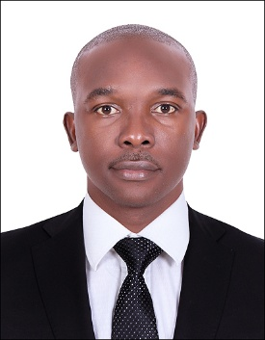
PERSONAL DATA
Current Location : Dubai, UAE
Nationality : Zimbabwean
Email : kuziwa.344584@2freemail.com
Date of Birth : 10-09-1983
Civil Status : Married
Languages Spoken : English and Shona
Work Experience : 6 years

CAREER OBJECTIVES
To obtain an accounting position where I will be able to contribute my skill, knowledge and experience to an organisation that will give me the opportunity to develop my career

INTENSIVE KNOWLEDGE OF:
- Accounting principles and procedure
- Handling bookkeeping activities and fixing accounting errors
- Knowledge of accounting software and processes
KEY COMPETENCES AND SKILLS
- Strong attention to detail, organisational and time management skills
- Good command over calculations
- Accounts payable, accounts receivable and invoice payment
- Bank reconciliations
- Financial statement preparation and analysis
- Ability to work with integrated accounting software and reporting system
- Fast and flexible leaner
- Proficient with MS Office suite, Pastel and Quick Books
- Inventory management and control

WORK EXPERIENCE

BSi Steel Zimbabwe
Zimbabwe Harare
Position: Assistant Accountant
Period: 4years

Responsibilities:
- Handled daily data entries, sales receipts, bank account transactions and reconciliations
- Oversaw accounts payable and receivable functions
- Verified invoices and various documents for accuracy
- Assisted with audit preparation and year end closing
- Handled tax returns and compliance with statutory requirements
- Preparing outstanding debtor list and making payment follow-up

Standard Chartered Bank Zimbabwe
Zimbabwe Harare
Position: Banking Intern (Transaction Banking)
Period: 2 year
Responsibilities:
- Managed cross-border trade for corporate and bank clients
- Processed electronic and paper base transactions
- Providing trade and supply chain financing solutions to both SMEs and corporates for import/export requirements
- Document processing and trade risk mitigation
- Managed Real Time Gross Settlement payment system
- NOSTRO accounts administration
- Respond to customer queries to inform them about the status of their transactions

EDUCATION QUALIFICATION
Bachelor's degree in Economics
ACCA (Studying)
Advanced level 2001(Murewa High School)
Ordinary level 1999(Mazowe High School)

