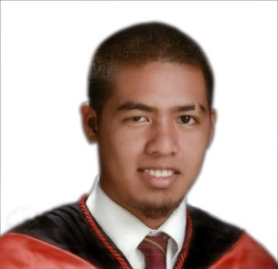
RYAN

C/o-Contact #: +971505891826
Email Add.: ryan.344621@2freemail.com

OBJECTIVE
I am seeking a competitive and challenging environment where I can serve an organization or individual and can establish a career for myself.

PERSONAL INFORMATION
Age: 25 years old
Date of Birth: June 4, 1991
Place of Birth: Manila, Philippines
Gender: Male
Height: 5’7’’
Weight: 85 kgs.
Civil Status: Married
Religion: Roman Catholic
Nationality: Filipino
Languages: English, Filipino, Basic Japanese
Dialects: Cebuano

HIGHLIGHTS OF QUALIFICATION
- Computer Literate (Adobe Photoshop, Microsoft Word, Excel, PowerPoint Presentation and Internet Research).
- Highly organized, with great attention to detail and follow-through.
- Flexible, able and willing to learn new things.
- Professional and with strong work ethic.
- Outstanding customer service skills, diplomatic and patient with all types of individuals and organizational levels.
- Ability to organize, prioritize and work under extreme work pressure, heavy work load and deadlines.
- Tolerant and flexible, adjusts to different situations.

EDUCATIONAL BACKGROUND
Vocational Education: TESDA - Pipe Fitting NCII Jan 2017 - Feb 2017

College Education: Negros Oriental State University 2007 - 2012
(BSIT) BS in Industrial Technology
Major in Architectural Drafting

Secondary Education: San Miguel National High School 2003 - 2007

Elementary Education: Bacong Central School 1997 - 2003

JOB EXPERIENCED

Sales Executive
Sales Department
Sanitary Care Products Asia, Inc.
Soong, Mactan, Lapu-lapu City, Cebu
March 2015 - September 2015

Quality Analyst, Editor, Typesetter

Publishing Services & Solutions

SPI Global

LP Information Technology Park, Jose Romero Rd, Dumaguete City, Negros Oriental
March 2013 – January 2015

Customer Service Representative
Qualfon Dumaguete
Dr. V. Locsin cor Real St., Dumaguete City
November 2012 – February 2013

Municipal Draftsman
Engineering Department
Bacong Municipal Hall
Bacong, Negros Oriental
March 2011 – November 2012

