CURRICULUM VITAE

NAME: KARTHIKA  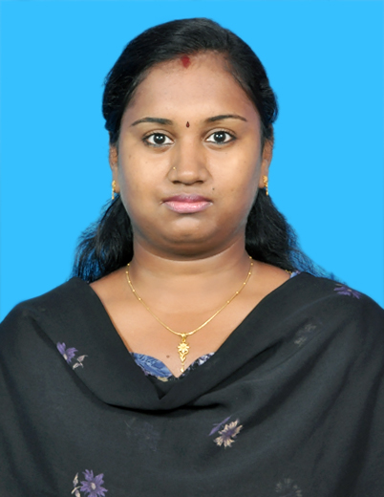  PHOTO  E-Mail: karthika.344629@2freemail.com  C/o-Phone no:+971502360357  Personal Data:  Date of Birth : 14 June 1988  Sex : Female  Nationality : Indian  Marital Status : Married  Husband’s Name: G.Srinivasan  Proficiency : Tamil English(Oral & written), Telugu(Oral) | Career Objective  To build upon my present knowledge and to contribute towards the growth of professionally managed organization with my skills and experience, leading towards my growth and development.  Professional Qualifications  Completed B.Tech [I.T] from SaraswathiVelucollege of Engineering,Melvenkatapuram,Sholinghur-631 102, Vellore district,Tamilnadu.  (Affiliated to AICTE , Tamilnadu)  Aggregate Percentage of my graduation  79%  Academic Qualification  Exams Board/University Percentage  TENTH Anglo-indian 87.5  TWELFTH State Board 86  Computer Skills  Software Technical Support: Level 1Basic troubleshooting of desktops &laptops, server monitoring  Operating system : Various versions of Windows OS  Customer support : Expertise in handling phone calls by following phone etiquette, drafting of emails, handlind different kinds of customers, ticket creation and handling.  Extracurricular Activities  - Won Scholarship of Rs.3000 for securing more than 75%in each year during the degree course.  - Won first prize in “ENGLISH SPEECH COMPETITION “during college festival days continuously for three years.  - Took technical seminars like “VIRTUAL REALITY”,”VIRTUAL PRIVATE NETWORK” and many other general seminars.  My strengths  - Good team player  - Patience and dedication  - Flexible and easily adaptable  - Proficiency in communicating with customers in a legible format.  - Straight forward  - Practicing to overcome my weakness without hurting anyone  My weakness  - Difficulty in saying NO if anyone asks for some help – This makes my situation harder if I am struck with some other important work and if someone approaches me for help at that time.  Work Experience  Present Employer:  HCL Technologies, Sholinganallur,India  Period: Feb 2016 – Till date  Position: Analyst in Integrated Command Center  ROLES &RESPONSIBILITIES:  - Acting as the first point of contact for the CLIENTS by identifying and reporting any major outage which causes business impacts.  - Proficiency in coordinating the technical tracks with the clients by acting as a bridge for find the Route cause of the problem and figuring out the best solution  - Adept in handling different scenarios with highly professional and smart approach for providing customer satisfaction  - Expert in multi-tasking – Monitoring the software tools for identifying the major outages, creating incident tickets to the technical tracks for resolution, generating reports for constant follow ups and building a good RAPO with the clients, technical tracks and customers by acting as a hub.  Previous Employer:  HCL Technologies, Navallur,India  Period: Sep 2010 - July 2012  Position: SeniorAnalystin Service Desk  ROLES & RESPONSIBILITIES:  - Have been the first point of contact for the customers for addressing their system issues via phone and email.  - Logged tickets (Incident/Request) according to their queries and assigning the same to the respective teams for further resolution.  - Try to troubleshoot and resolve the first level of system hardware and software issues  - Having constant follow-up of unresolved tickets in order to have timely resolution to customers.  - Escalating the unresolved tickets to the higher authorities by bringing them to their knowledge.  - Having basic knowledge of networking and windows for helping customers in their system connectivity issues.  - Acting as a good team player  Declaration  I hereby declare that the above-mentioned information is correct up to my knowledge and I bear the responsibility for the correctness of the above-mentioned particulars.

