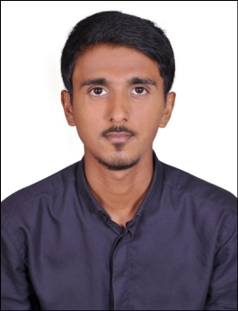
MOHAMMED

MOHAMMED.344647@2freemail.com

CAREER OBJECTIVE

Seeking a challenging position in a result-oriented company that allows me to utilise my analytical, mathematical and people skills in achieving personal as well as organizational goals.

EDUCATION

- Bachelor of Commerce, St. Aloysius College, Mangalore-Karnataka, 2016, with First Class.

- Diploma in Investment Management, 2016.

- Pre-University Course, Karnataka Board of the Pre-University, 2013, with First Class.

- Secondary School Leaving Certificate, Karnataka State Board of Secondary Education, 2011, with First Class.

SPECIALISATIONS

- Security Analysis, Portfolio Management and Taxation.

- Human Resource Development.

PROJECTS UNDERTAKEN

- Financial performance of Peter England (Tini Mini Company Limited).

- Human Welfare Association survey.

- Mangalore Refineries and Petrochemical Limited (MRPL) survey.

COMPUTER SKILLS

- MS Office

- TALLY

- Adobe Photoshop

WORK EXPERIENCE

- Accountant, Sahil Aluminium Company, Karnataka – India, 2015.

- Volunteer Education Activist, Human Welfare Trust (NGO), Karnataka – India, 2014.

- Lead Team Organizer and Designer, Nebulus, Karnataka – India, 2016.

PERSONAL DETAILS

Interests & Hobbies : Sports, Travelling, Photography and Cooking.

Winner of several business quizzes, computer club contests and festival competitions at College.

Event Head of Business Quiz ACME, a national level commerce festival organised by St. Aloysius College, Mangalore, 2014.

Date of Birth : 10th of April, 1995

Marital Status : Single

Visa Status : Visit Visa expiring on 25th of April

