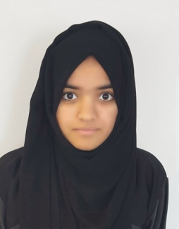
Hifza
C/o- +971505891826|D.O.B 12.01.1997
Email: hifza.344660@2freemail.com

As an ambitious individual with 3 years of sales experience I am often recognized for my commitment, motivation and customer interaction. Handling multiple tasks on daily basis competently and progressively under pressure.

- Data Analysis Research and Reporting
- Influencing and Negotiation
- Team work and Flexibility
- Initiative and Problem Solving
- Sound knowledge Ms Office
- Excellent Communication Skill
- Customer Service

Experience
Sales Executive
Jacob Sardini - January2016 – Present
Responsible for doing as much as sale possible, making customer aware of our products quality and provide further assistance if required
- Cultivated relationships with clients and maximized business opportunities.
- Prepare, present and follow up with customers on quotations.
- Focused on maximizing the customers shopping experience.
- Keeping the record of sales
- Handling customer payments, refunds, complaints, compliments, etc
- Open and close cash registers, performing tasks such as counting money, separating charge slips, coupons, and vouchers, balancing cash drawers, and making deposits
- Maintain knowledge of current sales and promotions, policies regarding payment and exchanges

Promoter

- Young Entrepreneur’s Competition, Dubai, UAE - March 2013, April2016
Responsible for Organizing the stall and sale of Pakistani consumer goods. Maintaining records of sales & profit, managing stock availability and preparing invoices
- Emirates Vision Events Management – 2015
Responsible for selling the tickets and allocation of seats and keeping the track of sales.
Establishing, maintaining and developing relationships with vulnerable people. Covering reception and greeting visitors mentoring and training new volunteers
- Gitex – 2014
Providing information to customers about the product and advice if required
Making sure sales runs smoothly.
Providing product satisfaction to the customer and keeping record of sales
- Americano -2016
Sampling products, explaining the customer about the price range and product availability and its offers, Influencing customer to purchase the product
- Canadian Beef -2016
Sampling products, explaining the customer about the price range and product availability and its offers, Influencing customer to purchase the product

Education and qualification

The central school - 2016
CBSE – Intermediate
New Indian Model School - 2014
CBSE – Metric

Personal profile

Nationality: Pakistan

Visa Status: Residential father’s sponsorship
Residence location: Dubai
Languages: English, Urdu

