IMRAN

Personal Details

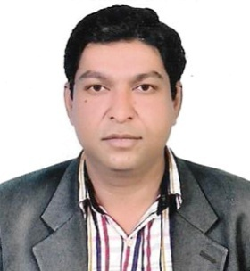
- Date of Birth : 20-08-1983
- Domicile : Bahawalpur(Punjab)
- Religion : Islam
- Marital Status : Single
- Nationality : Pakistani
- C/o-Contact No : +971501685421
- Email : imran.344674@2freemail.com

Academic Qualification

Degree | Year | Marks | Board
Radio Graphy & Imaging technology | 2016 | 352/600 | Punjab Medical Faculty Lahore Pakistan
Experience

- 1 years’ experience in CAT SCAN as a Technician.
- 1 years’ experience in MRI & FLOROCOPY.
Computer Skills

- MS Word
- MS Excel
- Power Point
- Internet Using
Reference

Will be furnished on demand.

