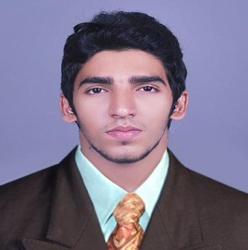
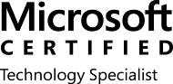
SHAFI
IT Professional
E-Mail: shafi.344716@2freemail.com
C/o-MOBILE: +971502360357

CAREER OBJECTIVE
Desire a challenging Network and System Engineering career in a professionally managed, progressive firm to utilize my quality driven professional ethic, result oriented personality, creative problem solving skills while exploring growth opportunities in the IT Industry.

PROFILE

- Having more than 4 year’s Experience in IT field
- High passion in System Administration and Networking
- Microsoft certifications.
- Well versed with installing, configuring & administrating of Microsoft Windows Server 2008/2012.
- Ability to adapt to any environment and gain the required knowledge in short time
- Self-confidence and willingness to learn
- Ability to research and solve new problems.
- Marketing executive quality relates with billing software installation.

PROFESSIONAL EXPERIANCE

BOOTING IT Solutions as Hardware Support Technician
[JAN 2013-Mar 2014 &Oct 2014-DEC 2016]

Professional responsibilities: Hardware Support Technician
- Installed and configured software to client standards
- Configure new hardware, install and update the software packages.
- Carry out in-house system testing
- Travel to client locations as per requirements
- Handled various types of Customer complaints
- Resolved many computer hardware problems.
- Removed kinds of viruses, Trojans, malwares.
- Installed and updated different type software including antivirus
- Remove unused files and software to put the software all the computer in their functional order.
- Resolve network issues as and when required
CODEPRO SYSTEMS, INDIA as IT Assistant
[APR 2014-SEP 2014]

Professional responsibilities : IT Assistant

- Installation of Hardware& software.
- Troubleshooting Hardware& software
- Cabling, crimping with i/o box and testing
- Installation and configuration of windows server and other OS
- Assigning IP address in desktop computers

EDUCATIONAL QUALIFICATION
Bachelor of Computer Application (BCA) -
from UNIVERCITY OF CALICUT

ACADEMIC PROJECT
BUILDING CONSTRUCTION SOFTWARE

TECHNICAL CERTIFICATION
- Microsoft® Certified Solutions Associate– MCSA
Certification : Number:E953-0805
Certification/Version : Windows Server 2012
TECHNICAL SKILLS
Hardware
- Assembling and Troubleshooting of PC
- Installing and configuring Windows 2000, 2003, XP,vista,server2008,
windows7, Windows 8,Windows 10, windows server 2012.
- Install hard drives, Ram, Network cards, Video& Audio devices.
- Hardware &Software installation
- Local & network printer installation

Windows Server:

- Windows Server : 2008, 2012
- Client OS : XP, Vista, 7, 8,10.

PERSONAL DETAILS
Nationality : Indian
Date of Birth : 27-03-1992
Marital Status : Single
Languages Known : English, Malayalam, Hindi and Arabic

REFERENCES

- References will be submitted upon request.

