WASI
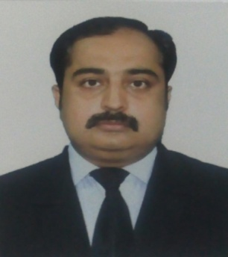
SKILLS:
- Organizational skills
- Problem analysis & solving
- Attention to detail
- Customer behavior management
- Team work
- Stress tolerance
- Communication skills
AREA OF EXPERTISE:

- Priority Customer Handling
- Front End Customer Services
- Manage of In-bound queries
- Handling of Kiosks customer
- Investigation of complains
- Tele-marketing & up-selling
- CRM’s (Seibel, Jupiter, E-Front & E-point )
- Customer portfolio management
- Shift Highlights and MIS Reporting
- Follow up sales lead
ACHIEVEMENTS:

- Employee of the Month
- Surprise Award
- Best Team Supervisor
- Team of the Month
- Advised Quality Assurance for SOP’s Modification
contact info:
M: +971-505891826
E: wasi.344725@2freemail.com
Visit Visa
Customer Service Professional

CAREER SUMMARY:

Customer Services Industry – 12+ Years
(Call Center, Customer Services, Front-end plus Sales 6 years)

Mobilink GSM Pakistan (Aug 2003 – June 2016)

Mobilink is Pakistan’s, subsidiary of “VimpelCom.Ltd”, a leading provider of voice and data services with 38 million subscribers, Covering 20000 cities, towns and villages with 9000 cell sites, direct employing over 2300+ persons. Mobilink maintains market leadership in Mobile telephony, WiMAX, VoIP, DSL, PCO and Mobile Banking with Revenue of Rs. 104 billion (2016)

- Mobile Phone Banking – Mobicash Commercial Sales

Assistant Team Lead

- Shift Highlights and MIS Reporting
- Resolve Escalated Cases
- Training, Mentor team KPI’s and Service Level Management
- Suggest Improvements and maintain Sales records regularly.
- Resource Adequacy Maintains communication equipment by reporting problems.

- Investigation & Resolution Unit (IRU)- Backend Operations

General Complaint Team

- Resolve customer’s request, complaints and queries
- Follow up where necessary
- Compile & maintain case logs as per the SOP’s.

Call Cord Team

- Provides OMT switch related status and performing execution
- Customer Information Management
- Compile call logs and assigning classification to customer
- Customer Tele-verification and activation
- Special support to international roaming customers

GPRS Team

- Up-selling of data packages, provides support for Data Services to Customer
- Trouble shooting, activation /deactivation, addition of MSISDN in U-power or MMS activation.

- Call Center / Contact Center Team /Out-door Sales

- Answering inbound calls, Up-selling, and information desk
- Sending Sales lead through CRM to relevant department
- Perform OTA setting for GPRS activation and process services activation
- Making customer complaints and send to relevant department as per SOP

EDUCATION / TRAINING
Bachelor of Commerce - University of Karachi – 2004

TRAININGS

- Leadership by Inspiration | - MS Office 2008 | - Culture of Excellence
- Calling in Life | - Building Blocks for Leader | - Leadership Excellence
- Conflict Management | - Emotional Intelligence | - Stress Management

