 | ISMAIL | 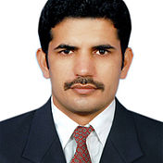
CURRICULUM VITAE
Personal information
Name

Address | In Dubai
Mobile | +971501685421
E-mail | ismail.344774@2freemail.com
Nationality  Licensed | PAKISTANI  Medical Laboratory Technologist Laboratory Allied Healthcare
Date of birth | 08/01/1987
Desired employment / Occupational field | Medical LAB Technologist
Work Experience
Duration | 06/01/2014 – 21/11/2016
Designation | Head Technologist
Main activities and responsibilities  Organization | To ensure the quality assurance of the reagents and equipment’s of haematology laboratory.  Maintenance of systems (Manual, Automation) and working with Quality Controls of all equipment’s.  Worked in Haematology and Special haematology. Working on Abbott Rubby system and Sysmex XE-5000 and SP 1000i and for coagulation and special coagulation CA -1500.For thalassemia Bio red D -10. For manual staining and bone marrow slide preparation and staining. Well expert in differential leukocytes counts.  Well specialized in Biochemistry & Special Chemistry and also in Haematology and Microbiology Departments.  SHIFA INTERNATIONAL HOSPITALS LIMITED, Islamabad, Pakistan
Duration | 01/03/2006 –31/03/2007
Designation | LAB Technologist
Organization  Duration  Designation  Main activities and responsibilities  Organization | Bio Path Lab and Diagnostic Centre Rawalpindi  20/11/2007 - 30/09/2009  LAB Technologist  Training of 2 years as Medical Laboratory Technologist  Baqaie Medical University Karachi Pakistan
Education and Training | 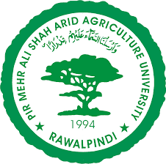
Session | 1/11/2010 - 1/11/2013
Title of qualification awarded | Master of Science (M.Sc.)
Principal subjects / occupational skills covered | Biochemistry
Name and type of organisation providing education and training | PMAS-Arid Agriculture University, Rawalpindi
Session | 20/11/2007 - 30/09/2009
Title of qualification awarded | Bachelor’s degree (B.Sc. MLT)
Principal subjects / occupational skills covered | Micro technique and Elementary Anatomy  Clinical Pathology and Serology  Haematology and Blood Banking
Name and type of organisation providing education and training | Baqaie Medical university Karachi
Certificate  Personal skills and competences | H.S.S.C (Pre. Medical, 2004-2006, FBISE)  S.S.C (Science, 2002-2004,FBISE)
Mother tongue | URDU
Other language | English
Computer skills and competences  REFERENCES | 1- Operating system Ms Window 98/2000/XP/7  2- MS Office ,Typing tutor Biological software annotation, Internet browsing  3- Hard ware & Trouble shooting Software & Hardware installation  Will be furnished on demand.

