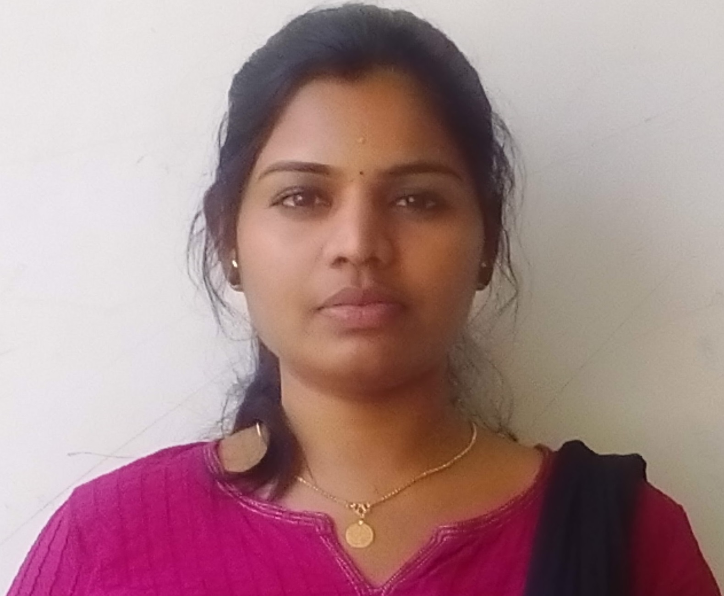
SANDHYA DAS
Curriculum Vitae

MEDICAL ADMINISTRATOR

Contact Details:

055 3203736

DUBAI
Sandhyadas234@gmail.com

Please scan to capture contact details

Objective | As an accomplished individual with a rapidly increasing range of industry experience, I believe I am someone who will be an asset to your firm. With strong instincts and a proven record in the areas of Front office, Customer relationship, Administration, and Operations. I would like to explore the possibility of putting my skills and experience to work for you.  As you can see from my enclosed resume my career en compassesroles in coordination, collaboration and overall leadership. However, I am confident that my training, skills and my background will suit you perfectly. I am someone who consistently delivers top quality results no matter what the challenge.  Among my other strengths, I have solid professional Instincts and have been successful in cultivation reliance and long term relations with all my employers, clientele, key staff & professionals. Persuasive, self-confident and effective, I have proven to be a respected and valued employee in the past.  My dedication to excellent performance, ability to interact professionally with all levels of personnel and my drive to grow in this field make me a value-added asset to an organization such as this.  I would be pleased to have the opportunity to discuss the future employment and look forward to speak to you soon. Feel free to contact me at below providednumber.
Date of Birth | 22- OCT- 1990.
Nationality | Indian.
Education | MBA IN HOSPITAL ADMINISTRATION DISTANCE EDUCATION FROM ISBM (PURSUING) B.COM –Karnataka university
Computer Skills | Operating System : Windows xp,7,8,10  M.S Office, Good typing speed, Internet Knowledge
Work experience | - Worked in SALES Department ,GTM Teleshopping Pvt. Ltd, Hyderabad  - Worked as a CCE in Aegis pvt ltd , Hyderabad  Duration: March 2011-April 2012  - 1 Year experience of Front Office Billing Executive  (OP & IP) at Aaron Hospital, Narsinghi, Hyderabad  Duration: May2012-June 2013  - 1.5 Years’ experiencein Front Office Billing Executive in Vijaya Diagnostics Pvt Ltd, Hyderabad  Period: September 2013-Januvary 2015  - Asst.Manager-CR&FD In charge at first health diagnostics Pvt. Ltd ,Hyderabad  Period: January 2015-January 2017
Personal attributes | - Have a strong sense of responsibility. Pleasing mannered and studious nature. Tactful  And can mingle well with people.  - Possess excellent communication skills  - I am quite analytical and perceptive by nature and believe in using all my abilities  to face challenging risks.  - I have been trained to work well under pressure and always be on time during the course
Interests and activities | Travelling, Reading books, listening to music etc.
Languages | English, Malayalam, Hindi, Telugu, Tamil.  EXPERIEN EXPERIENCE as F.D In Charge, Medical Administrator & Asst .Manager CRM  - Organizing all the front office and dispatch related works.  - Planning and delivering CRM strategies across the company encouraging customer retention and customer loyalty.  - Working closely with all departments to ensure the CRM works effectively for all aspects of the company.  - Overseeing direct communications with customers through the CRM.  - Overseeing the migration of all direct communications to lower cost mediums such as SMS and email.  - Provide general administration support to M.D.  - Organizing internal meetings attending them and taking minutes.  - Contribute to the overall development of first health diagnostics and its activities.  - Maintains the total stock of materials and issues as per the requirement.  - Supports internal operations.  - Ensure necessary records are maintained that can readily provide current, accurate and accessible information.  - Releasing Referral amount to Doctors monthly with doing statements and take caring of their calls.  - Support the Managing Director in the preparation and presentation of reports, proposals, budgets and related activities in servicing and developing contracts and relationships with other vendors.  - Order and maintain proper inventory levels of medications, controlled substances, diagnostics supplies, equipments.  PERSONAL DETAILS  FATHER NAME : V.K Shivadas  NATIONALITY: INDIAN  STATE: KERALA  DATE OF BIRTH: 22/10/1990  SEX: FEMALE  MARITAL STATUS: UNMARRIED  PASSPORT NO: P 6657412  EXPIRY DATE: 29/12/2026  ADDRESS :  SANDHYA DAS  BUR DUBAI  U.A.E  Mobile: 055 3203736  E-mail: sandhyadas234@gmail.com  REFERNCES:  Will be provided upon request.  VISA STATUS: VISIT VISA  DECLARATION:  I hereby certify that the above mentioned details are true and correct to the best of my knowledge.
Date :

Place :DUBAI Signature

*****

