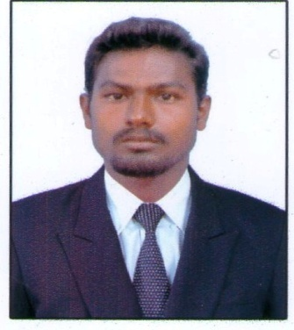
KARTHIK
C/o- +971501685421
Karthik.344827@2freemail.com

summary
A high performing civil engineer who has considerable experience of working on infrastructure, utilities, geotechnical, structural, highways, drainage and flood prevention projects. Craig possesses a strong desire to work on exciting and diverse projects that really make a difference to people’s lives. He is committed to providing a high quality service delivery to every client and project he works on, and is currently looking for employment in an open, friendly and professional environment where ideas are shared and opportunities seized.
Skills:
Professional
Customer focused , Financial management , People management , Quality assurance , Conducting research, Risk assessments , Planning regulations
Personal
Problem solving Professional manner, Safety conscious, Can handle stress, alwayspro-active, Attention to detail, Logicalthinker, Communication skills
Engineering
Site supervision, Waste infrastructure, Structural engineering Carrying out site audits, Estimatingtechniques, Architectural design, Engineering concepts
Computer Skills
- Auto Cad
- M.S Office
Working experience
- Working as a site engineer in virarahavan civil engineer and contractor
- Site experience in inspecting of daily works.
- Preparation of material & technical submitted for project approvals.
- Preparation of drawings
- Site experience in quickly troubleshooting and resolving site issues.
Duties
- Assisting in the supervision of civil, building works or services contracts.
- Challenging structural architects in terms of proposed solutions i.e. construction cost, technical requirements, sustainability, suitability or quality.
- Delivering assigned tasks for airport design & infrastructure development projects.
- Surveillance and review of structures, design plans and drawings.
- Preparing and reviewing documentation for regulatory approvals and contract issues.
- Preparation of drawings, reports and specifications.
- Ensuring compliance with all project QA procedures and requirements.
- Sustaining client relationships and developing new business.
- Preparation of bids and monitoring of project costs and progress.

PROJECT DETAILS
- Study of road junction at sholinganallur with respect to pedestrian safety. In which we consider to provide a good road junction facilities at a place of sholinganallur. By the way we are improving the transport system with less accident and to improve pedestrian safety at this junction. Finally we may suggest to provide accident control system like a subway, signals, mediators, widening of road, fly over, road marking, appropriate drainage facility, and so for.
EDUCATIONAL QUALIFICATION
- B.E Civil Engineering
Prathyusha institute of technology and management (affiliated Anna university) 75 %( 2010-2014)
- Diploma in civil Engineering
Sri Sitheswararpolytechnic college (Anna university DOTE) 92.5 %( 2009-2011)

PERSONAL DETAILS:
Dob :01-06-1992
Sex :Male
Marital status : Single
Nationality : Indian
Languages known : Tamil,English

