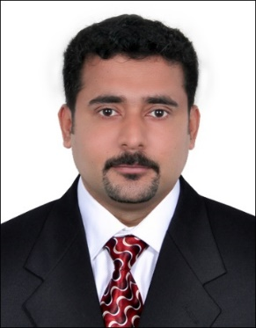
BIO DATA

Shine

C/o-Mobile : +971504973598
Email : shine.344833@2freemail.com

Career Objective
Seeking a challenging job profile providing expertise and knowledge to find a work environment which will help enhance my skills and where can be part of a team that appreciates what I do, contribute to the goals of a firm and to seek a position commensurate with my skills and knowledge in an organization of repute.

Academic Qualification
Examination | Passing Year | Board /University | College
MBA | 2009 | M.G University | SreeSankara College, Kalady
B.Com | 2004 | M.G University | St. George College
Pre Degree | 2000 | M.G University | De Paul College
SSLC | 1997 | Kerala State Board | St. Sebastine Higher Secondary School

Computer Proficiency
- Conversant with windows Applications
- Adequate Knowledge in Accounting Software like ERP, Tally, Excel and Word

Working Experience
May 2012 to till date – Aries Marine and Engineering Services, Sharjah Designation: Senior Accountant
Job Responsibilities:
- Preparation of Budgeting and Analyzing of Reports
- Handling Receivable and Payables
- Preparation of Salary, Incentives, Bonus etc
- Preparing of Management and Financial Report.
- In charge of Branch Accounts
- Maintaining all accounts in tally and in ERP

August 2009 to May 2012 – Aries Telecasting Pvt Limited, Ernakulam
Designation: Accountant
Job Responsibilities:
- Data Entering of all accounts in Tally
- Cash Handling
- Preparing of Management reports
- Handled of both direct and indirect tax
- Handled Service tax, TDS, Income Tax preparation, fillings etc.
- Statutory Audit Assistance.
- Handled Receivable and Payables.

Year 2008 to 2009 – Save X,Ernakulum
Designation: Accountant
Job Responsibilities: Handled all kind of movie distribution work

Year 2005 to 2008 Vaisakha Distribution, Ernakulum
Designation: Accountant
Job Responsibilities: Handled all kind of movie distribution work

Project Handled
- Handled DAM 999 Movie project as Chief Accountant as part of Aries Group of Companies.
- Worked as Chief Accountant in St. Dracula Movie-a project of Aries Group of Companies

Personal Strength
- Quick learner
- Capable of handling pressure situations
- Good written and verbal communication
- Confident and self-motivated
- Good Inter personal skills
- Good at analytical thinking as well as lateral thinking

Personal Details

Date of Birth : 05.05.1982
Nationality : Indian
Marital Status : Married
Language Known : Malayalam, Hindi, English.
Hobbies : Watching Cricket, Playing Football.

Declaration:
Hereby I declare the above mentioned details are true with my best of knowledge.

