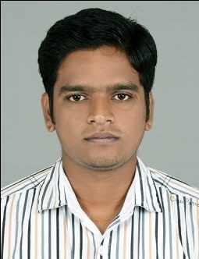
SALEESH
SALEESH.344847@2freemail.com

PROFILE SUMMARY

• Certified in computer hardware and networking
• Experienced PC technician in software/hardware computer repair.
• Troubleshooting, analyzing and repairing problems of computer elements such as desktop computers, laptops and various components/peripherals.
• Performing computer installation and operating system configuration in designated networks.

CORE COMPETENCIES

• Antivirus installation and virus detection.
• Appropriate driver search and installation.
• Hardware troubleshooting.
• Windows system cleaning.
• Problem analyzing and solving skills.
• Flexible to work in all conditions.
• Good knowledge of all the hardware and their management.

WORK EXPERIENCE

• Assembling the Computers.
• Configuration of the Computers with the internet.
• Solving the regular upcoming Hardware issues.
• Evaluating the network issues.
• Solving the technical issues of the employees.
• Connecting the printers with the desktops & laptops.

Technical Skills: Computer Hardware and Software Applications
• Operating Systems – Win XP, 7, 8, NT, 2013, OS X and Linux-based OS
• Microsoft Office suites – 2003/2007/2010
• Antivirus and firewall
• Various types of PC hardware such as, Apple/Mac, Dell, HP and Toshiba
• Hard drives, monitors, printers, scanners and video equipment

EDUCATION

• Certified Cisco Certified Network Associate, (year 2014)

• Certified Microsoft Certified Professional, (year 2010)

• Certified Computer Hardware, BSS information technology mission (year 2009)

• Plus two (science), Board of higher secondary examination, Kerala (year2005)

• S S L C General Education Dept., Kerala (Year 2003)

PERSONAL

Date of Birth : 26/04/1988

Gender : Male

Marital Status : Single

Nationality : INDIAN

LANGUAGE KNOWN

English, Hindi and Malayalam

PASSPORT DETAILS

Issued at | : Cochin
Date of Issue | : 06th January 2015
Date of Expiry | : 05th January 2025

