OBJECTIVE :
Seeking a challenging and Responsible position as a Chemical Engineer and willing to work as a key player leading and dealing effectively in a multicultural environment

CARREER SUMMARY :
Having experience in the field of process design, responsible for preparation of process data sheet, study of piping and instrumentation diagram, process flow diagram, block flow diagram, heat and mass balance, process description and preparing annual budget for the plant, preparing official letters and purchase requisition for the process to continue, maintaining the records for the chemicals.

EXPERIENCE SUMMARY :
Total Experience : 2 years

Position& company : Process Engineer Trainee
Madras Fertilizer Limited, Chennai
Period : August 2012 to May 2014

SOFTWARE SKILL :
- Aspen Hysys
- Auto Cad- Basic
- MS- Office
TECHNICAL SKILL (OIL ANG GAS) :
- Line Sizing
- Pump Sizing
- Pump Calculation
- Pump Curves
- Power Calculation
- Control Valve Sizing
- Pressure Safety Valve Sizing
- Separator Sizing
- Process Heat Transfer
- Distillation column Design
- Cooling Tower Process
- Storage Tank Design
- Selection of Tank
- Storage Tank Calculation
- Flare System
- Flare System Function
- Design Consideration of Flare System
- Material Selection
- Codes and Standard

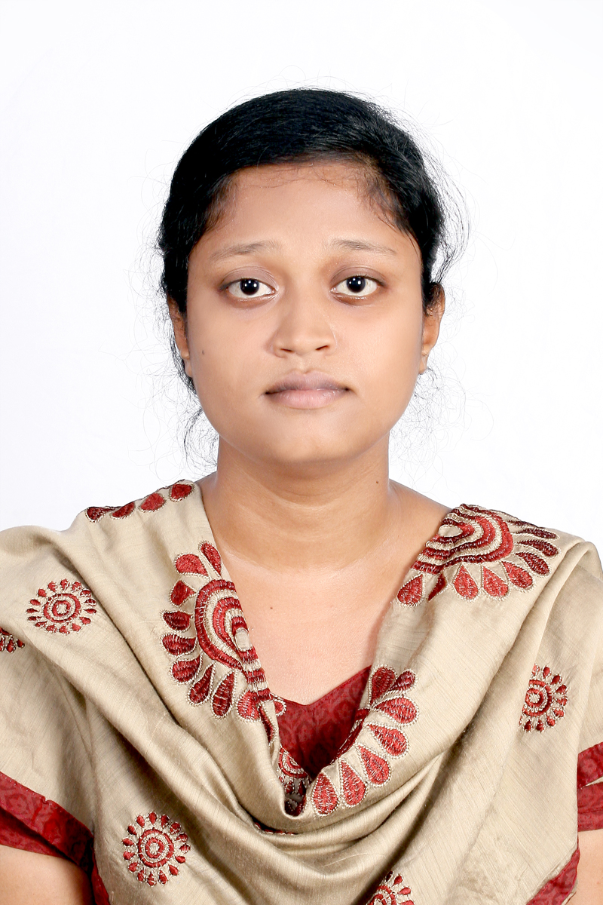

NAME
JASMINE

EDUCATIONAL
QUALIFICATION :

- B.TECH CHEMICAL ENGINEERING in may 2012
- PG DIPLOMA PROCESS ENGINEERING in October 2017

PERSONAL DATA :

Date of Birth : 17.10.1990
Gender : Female
Nationality : Indian
Marital Status : Married
design engineer, Dubai
Languages
Known : English, Tamil
Passport Details :
Date of Issue: 05.05.2016
Date of Expiry: 04.05.2026

Communication Address :
Al Karama,
Dubai

Contact No :
Mobile : +971501685421
Email ID :
Jasmine.344854@2freemail.com

EXPERIENCE DETAILS :
Madras Fertilizer Limited, Chennai
Designation: Process Engineer Trainee
Area: Process Engineering
Responsibilities:
- Study of Piping and Instrumentation Diagram(P&ID), Process Flow Diagram(PFD), Block Flow Diagram(BFD)
- Teaching the process techniques for the students who come for the training in the plant
- Trained in daily monitoring the process parameters and energy consumption levels of the plants from (DCS, Distributed Control System)
- Experienced in operating techniques of the plant process in ammonia, urea and utility plants comprising RO, TTP(tertiary treatment plant for sewage) and cooling water blow down treatment, DM (De Mineralized) water production and boiler operations inclusive of startup and shutdown procedures.
- Energy Calculation for the plant
- Familiar in maintaining the records and data entry for monthly inputs and ISO requirements.
- Planning and framing the annual budgets for all the chemicals and fuels consumed in the plants
DECLARATION
I consider myself familiar with chemical engineer aspects and the above information are true to the best of my knowledge and belief.

