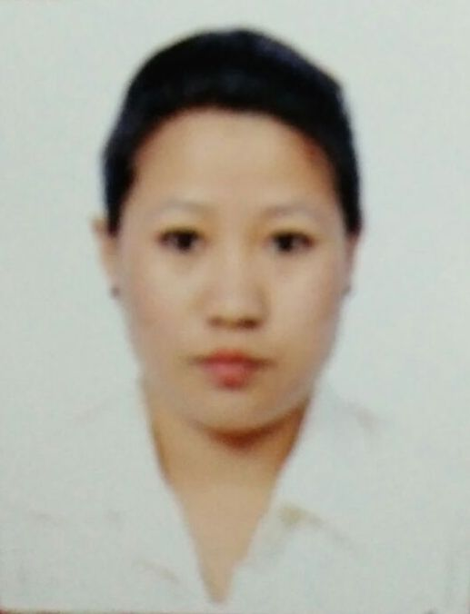
Curriculum Vitae
Sita

C/o-Mobile No: +971505891826
Country: Bhutan.
Email id: sita.344880@2freemail.com

Career Objectives
To obtain a challenging position wherein my professional skills, valuable experience and qualifications can be invested to the optimum level for a continuous career growth and to produce best result for the organization, I represent.

Highest Educational Attainment
- Higher secondary from MHSS(BCSE, Bhutan board)
Technical training
- Basic course (6 month), Certificate course in IT (Information Technology).

Work Experience
Organization: Nogosh For Hena
Beautician: 30th August, 2015– Till 30st January 2017
Responsibilities:
- Provide the necessary services to those who want to look beautiful at all times.
- Maintain a cheerful and warm disposition in dealing with customers at all times.
- Show the right values towards customers.
- Always available to attend to the needs of customers.
- Be updated with the latest trends in beauty services and technology.
- Aim to satisfy every customer.
- Maintain cleanliness and observe proper hygiene.
- Maintain good and proper grooming at all times.

Organization: My Mart
Sale Girl: 1st February, 2012– Till 1st 0ctomber 2014
Responsibilities:
- Consistently offer professional, friendly, warm and engaging excellent customer service.
- Work as a team to achieve the goal and target of the company.
- Responsible for stock take inventory and perfume proper merchandising.
- Responsible for all issued funds and maintain proper handover/takeover.
- Manage product returns and exchanges
- Exceptional ability to communicate and interact with individuals.
- Excellent in communication, interpersonal, and organization.
Strength
- Flexibility and adaptability  - I’m self-confident and can mould myself to all work environments  - Determine to learn with the practical approach | - Interpersonal relations and communication  - Punctual and hardworking  - Compassion and truthful

Language known
- English  - Nepali | - Hindi  - Dzongkha (National language)

Personal Profile
Date of birth : 1st January 1985
Nationality : Bhutanese
Passport Status : Working Visa
Deceleration
I hereby declare that all statements made above are true complete and correct to the best of my knowledge and belief.

