Serafin

Full-Stack Software Engineer

ㅡ

Skills

Rap

+9715023060357
Serafin.344900@2freemail.com

Front-End

Server Side

Tools and Application Platforms
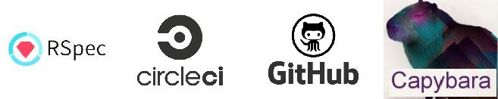

ㅡ
Experience GuideVine / Full​-Stack Software Engineer
NOV 2015 - PRESENT (1 year and 2 months)

GREATER NEW YORK CITY AREA

Responsible for designing, developing, and maintaining a highly distributed Ruby on Rails web application called GuideVine for a high performance, high traffic, advanced interactive site, by providing personalized matches that help users connect to expert financial advisors and content suited for their individual financial situation consumers and professionals.

Big Bad Goose / Full​-Stack Software Engineer
NOV 2014 - JAN 2017 (2 years and 2 months)
SAN MATEO, CALIFORNIA

Responsible for designing and developing highly distributed Ruby on Rails web applications for clients.

Duties and Responsibilities:

- Develop consumer based features using Ruby on Rails, JavaScript through CoffeeScript, jQuery, HTML through HAML, and CSS with Bootstrap.

- Collaborate with Product Management regarding module definition, schedule, scope, and project-related decisions.

- Develop best practices and architectures, including clean coding, optimizations, Test Driven Development (TDD) through Capybara and Circle CI, Behavior Driven Development (BDD) through RSpec, and pair based programming.

- Manage, collaborate, and coordinate the work with other development teams.

Fujitsu Ten Solutions Philippines, Inc. / Software​
Engineer

OCT 2013 - JUN 2014 (8 months)

MANILA, PHILIPPINES

Responsible for designing, developing, and maintaining PHP and CodeIgniter web applications as in-house software for the company.

Remarkable Contributions:

- Integrated Training Attendance Monitoring System for Training Section

- Developed a MySQL Database using ER Model in a Training Attendance Monitoring System

- Developed an existing system called Integrated Management System

ㅡ
Education Far Eastern University - East Asia College / B​.S.
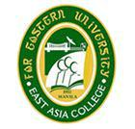
Information Technology

JUNE 2009 - OCTOBER 2014

SAMPALOC, MANILA

