JENELYN
C/o-Mobile No.:+971505891826
E-mail Address: jenelyn.344960@2freemail.com

CAREER OBJECTIVE
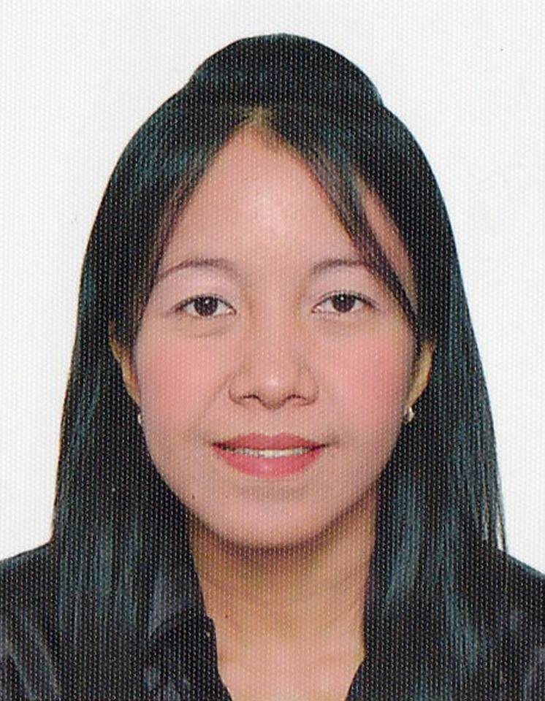

Educational Qualification
BACHELOR’S DEGREE
BACHELOR OF ENTREPRENEURIAL MANAGEMENT
QUEZON CITY POLYTECHNIC UNIVERSITY
Quezon City, PHILIPPINES
2006-2010

STATUS
VISIT VISA
Al Qusais 1 Dubai

SUMMARY OF QUALIFICATIONS
To support the growth and profitability of an organization that provides challenge, encourages advancement and rewards achievement with the opportunity to utilize my substantial experience, skills and proven abilities.

- Experienced in Sales and promotion.
- Computer Literate and Knowledgeable in MS Office.
- Experienced in Customer Service Representative.
- Possessed Expertise in doing paper works.
- Knowledgeable in Field work expertise in sales and promotion.
- Received telephone calls and keep records in day to day written communication.
- Expertise in Calendar Management.
- Experienced in handling cash and cheques collection.
- Planning, developing, implementing, monitoring and evaluating project to promote health improvement.

Professional Insights Marketing Services
(GLAXOSMITHKLINE)
Receptionist
Las Pinas, Paranque City
March 2014-January 2017

- Achieve agreed contract given by the company consist coverage and frequency targets and Detailing the assigned Doctors and deliver agreed customer centric activities within operating budget expense.
- Is in charge with the responsibility of providing a lasting impact on the success of the firm: to make a good first impression at all times.
- Contributes own initiative to asses client to get quota in sales and calls performance per month.
- Provides assistance in general administration duties including support to various departments.
- Promptly answers, routes and screens all questions from the MD’s and client with proper etiquette as per company procedure.
- Maintains a professional, credible, pleasant and sincere tone of voice when answering queries from the entire client.
- Receive payment by cash, check, credit cards, vouchers, or automatic debits.
- Issue receipts, refunds, credits, or change due to customers.
- Count money in cash drawers at the beginning of shifts to ensure that amounts are correct and that there is adequate change.

- Monitors and tracks documents to ensure that shipments are planned, scheduled and are delivered to different offices in a timely manner.
- Roles may vary from giving face-to-face advice to individuals to producing strategic policies for health promotion.
- Makes an inventory and ensures the availability and replenishment of samples given by the company.
- Keeps a record of all the incoming and outgoing written communications.
- Greet customers entering establishments.
- Maintain clean and orderly checkout areas.
- Establish or identify prices of goods, services or admission, and tabulate bills using calculators, cash registers, or optical price scanners.
- Receive payment by cash, check, credit cards, vouchers, or automatic debits.
- Issue receipts, refunds, credits, or change due to customers.
- Count money in cash drawers at the beginning of shifts to ensure that amounts are correct and that there is adequate change.
- Greet customers entering establishments.
- Maintain clean and orderly checkout areas.
- Establish or identify prices of goods, services or admission, and tabulate bills using calculators, cash registers, or optical price scanners.

- Processes all required documents for the provision of
orders and monitor stocks availability of the products
has been promoted to the hospitals, clinics and etc.

- Manages and updates the clients for the listing of new product available and maintain the sales of the product carried.

- Performs Calendar Management and manages the schedule of the training and seminar will be provided by the company.

- Performs the scheduling and planning of meetings and conferences will do for the product presentation for the hospitals, community etc.

- Hit the target sales quota and calls every month.

- Visit Doctors and client regularly.

Personal Details
Date of Birth:Sept. 28, 1981
Height: 5’4’’
Weight: 110 lbs.
Nationality: Filipino

Knowledge, Abilities & Skills

Proficient in the following:

- MS Word, MS Excel, MS Powerpoint and the Internet
- Multitasking
- Oral and Written English Communication.
- Providing Good Customer Service.
- Handling Customer Queries in a Professional Manner
- Ability to work independently or as part of team
- Ability to work under pressure
- Showing a positive attitude towards work

Language Spoken
English and Filipino

El EZBA RESTAURANT
United Arab Emirates
Waitress/Cashier
Dubai, Business Bay
January 2012 - October 2013

Zeutica, Inc.
(Pharmaceutical Company)
Valenzuela City Philippines
Medical Representative
July 2010 – March 2011

Duties and Responsibilities:
- Provided Above Satisfactory Customer Service.
- Created customer profiles for future references.
- Ensured the provision of Quality Customer Care.
- Communicated and coordinated with the Service Providers.
- Ensured that the Target Metrics are being met at all times.
- Handled customers within average handling time requirement.
- Making sure that the issue of the customer was resolved.
- Can handle irate customer in a professional manner.

Duties and Responsibilities:
- Promote pharmaceutical product to potential physician in a specific area given by the company.
- Provided Quality product and services in pharmaceutical industry.
- Promote pharmaceutical product in hospital, private and government clinic given by the company in specific area.
- Was in-charged in answering queries through mobilephone given by the company.
- Was in-charged in making appointments with the doctors for RTD and attending seminars and conference made by the company.

- Ask the Doctors to prescribe my product during the consultation, laboratory procedures and in getting the right medicine prescription.
- Was in-charged in processing Letter of Authorization for programs and activity to be done inside the premises of hospitals and establishments.
- Ensured that all payments are well-documented and updated.
- Attend seminars regarding product knowledge and customer service.
- Was in-charged in coordinating to other areas to endorse MD’s to be cover and visit regularly.
- Reported weekly to the office and scheduled set by the company.

Shangri-La Hotel
Makati City, Philippines
Receptionist
November 2003 – April 2004

- Assist customer with royalty treatment
- Always attend customers while inside the hotel
- Attend customers with warmth and comfortable greetings
- Handle irate customers with professional manners
Cherry Foodarama Supermarket
Quezon City, Philippines
Cashier
November 2002 – July 2003

- Receive payment by cash, check, credit cards, vouchers, or automatic debits.
- Issue receipts, refunds, credits, or change due to customers.
- Count money in cash drawers at the beginning of shifts to ensure that amounts are correct and that there is adequate change.
- Greet customers entering establishments.
- Maintain clean and orderly checkout areas.
- Establish or identify prices of goods, services or admission, and tabulate bills using calculators, cash registers, or optical price scanners.

