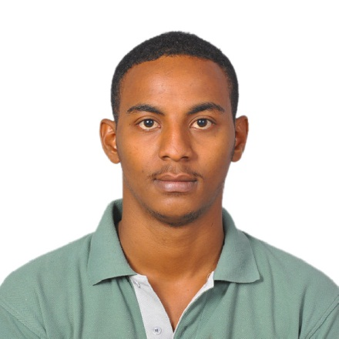
C/o-PHONE NUMBER: +971503718643
Email: atta.344991@2freemail.com
ATTA
OBJECTIVES
To obtain a position in a strategic organization where my skills and experience will be an assist to help the company achieve their mission, vision, and values. To contribute to a company while still developing my knowledge and abilities.

PERSONAL INFORMATION
Nationality: Sudanese
Gender: Male
Material Status: Single
Age: 24
Visa status: visit visa–Transferable
Current Location: Dubai – UAE

QUALIFICATIONS
- Bachelor ofComputerApplications (B.C.A)fromOSMANIA UNVERSITY-HYD-INDIA (2014).

- Hardware, CCNA, MCSE2012(Microsoft Certified Solutions Expert) & Linux Courses From Zoom Technology -HYD-INDIA (2014).

- Part time English proficiency course form EFLU University-HYD-INDIA (2014).

EXPERIENCES
April. 2016- novmber 16 Weeks
Location:Eastern sudan kassalaPRACTICALACTION
Job title:IT DEPARTMENT
Description:I work as Admin And is including field visits,lecturs,personal assignments reporting and exposure to rural development programmes and principles
(My main role in the practical action is to work it department)
- Installing and configuring computer hardware operating systems and applications.
- Troubleshooting system and network problems and diagnosing and solving hardware or software faults.

3.customers’ cases and applications.
EXPERIENCES

LANGUAGE SKILLS:

- Arabic :( native).
- English: speaking English fluently, reading and writing.
- Hindo; fair.

PERSONAL SKILLS:
- I have good knowledge with most of Microsoft products.
- I have good knowledge in Exchange server ,and outlook .
- Ambitious and willing to learn.
- Effective oral and written communication skills.
- Ability for team work.
- Ability to work under high workload pressure.

