**UDANAN**

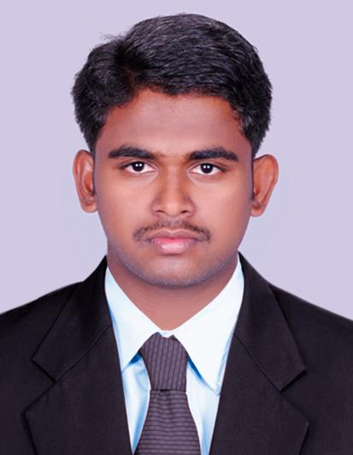

*E-mail:*

[Udanan.345001@2freemail.com](mailto:Udanan.345001@2freemail.com)

Mob: +971502360357

*Personal Information*

Date of Birth: 09/04/1992

Nationality : Indian

Visa status : Employment visa

Expiry date : 04/04/2017

*Languages Known*

English, Malayalam, Tamil&

Hindi

p

R

OF

I

L

E

**ACADEMIC RECORD:**

**Technical**

* **NETWORK ENGINEERING**fromACCEL IT Academy Trichur, Kerala(**CCNA,MCSE,CWNA,LINUX,FIREWALL**)

**Academic**

BACHELOR’S DEGREE

University of Calicut,Kerala, India

**WORK EXPERIENCE :**

1. QUEE NETWORK SOLUTIONS

Duration : May2011 to April 2012

Position : Hardware and networking technician

1. NEXT EDUCATION INDIA PVT.LTD

Duration : January 2013 to march 2014

Position : Technical Support Engineer

1. TECHNOWAVE ID SYSTEMS PVT.LTD

Duration : June 2014 toFebruary2015

Position : Technical Support Engineer

4. THANGAM JEWEL LLC- DUBAI

Duration : March 2015 to present

Position : IT Support &Back office

**Responsibilities** :

* **I**nstalling software, patching, upgrading and maintenance of operating system.
* **I**nstall, upgrade and maintenance of server.
* **C**onfiguring DNS, DHCP, ADS,&File Server in

2003,2008,2012&2013 server.

* **E**stablishing Firewall Operations Performed system startups and shutdowns.
* **R**esponsible for supervision of backup and disaster recovery operations.
* **H**andling networking connection between offices
* **I**nstall and maintain various servers,printers and backups
* Repair and troubleshoot barcode and id card printers

.

**COMPUTER PROGRAMMING SKILLS:**

* Programming Language: C, C++
* Hardware Tools:TC/IP configuration LAN and Networking.
* Operating Systems: Windows9X, Windows2000, Windows ME, Windows XP, Windows Vista, Windows 7
* Office Package: Microsoft Word, Microsoft Excel, Microsoft Access, Microsoft PowerPoint, Microsoft Outlook Express

SKILLS/ABILITIES/KNOWLEDGE:

* Hardware knowledge such as CPU, Memory, Disk, Network, Bios. .
* Excellent in MS Word, Excel, PowerPoint, Outlook.
* Install complex software and hardware.
* LAN and WAN configurations.
* TCP/IP fundamentals.
* Router configuration
* Active directory, Domain Name Service, DHCP.
* Basic knowledge in Linux Server .
* Asset Tracking
* Windows server2003,2008,2012&2013 administration
* Knowledge CCNA,CWNA