To be a self motivated next generation leader with the ability to adapt rapidly changing technologies with a strong desire to undertake challenging job and to work with the team to achieve the goals of the organization.
CAREER OBJECTIVE
CURRICULUM VITAE
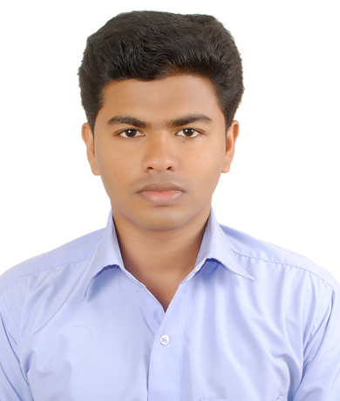
SANDEEP
Bachelor Of Engineering
In Electronics And Communication
Engineering (2008-2012)

Contact details

Email :
sandeep.345027@2freemail.com

Phone no:
C/o- +971502360357

PROFESSIONAL SUMMARY

- Bachelor Degree in Electronics and Communication Engineering.
- Overall 2 years and 6 month of experience in the development of Web & Enterprise applications using JAVA and J2EE Technologies.
- More than 1 year and 6 month of experience in the Substation Operation and Maintenance.
- Hands on experience in Core Java, JSP, PHP, Tomcat Web Servers.
- Knowledge of Eclipse tool for the development of projects.
- Proven abilities in testing, analysis and project co-ordination.
co-ordination
EMPLOYMENT HISTORY

FEB 2015 – JAN 2017 : ADHOC TECHNOLOGIES PVT LTD, TRIVANDRUM
DESIGNATION : SOFTWARE ENGINEER

RESPONSIBILITIES
- Software development includes Analysis, Design and Development of Android and Web-based applications.
- Expertise in Database Design, Creation and Management of Schemas, writing Stored Procedures, Functions, DDL, DML SQL queries.
- Expertise in different IDEs like Eclipse, Emma and Mysql.
- Execute full lifecycle software development.
- Documents and demonstrates solutions by developing documentation, flowcharts, layouts, diagrams, charts, code comments and clear code.

Passport Details:

Date of Issue : 21/11/2013
Date of Exp : 20/11/2023
Place of issue : Trivandrum

JUNE 2014– JAN 2015 : ADHOC TECHNOLOGIES PVT LTD, TRIVANDRUM
DESIGNATION : SOFTWARE ENGINEER TRAINEE

EMPLOYMENT HISTORY

TRAINED UNDER ADHOC TECHNOLOGIES PVT LTD
- Web-Designing
- Java-J2ee Programming
- PHP Programming
- Android Application Development

APRIL 2013–JUNE 2014 : KERALA STATE ELECTRICITY BOARD,KNLR
DESIGNATION : SUBSTATION OPERATOR

EMPLOYMENT HISTORY

RESPONSIBILITIES
- Records readings of switchboard instruments to compile data concerning quantities of electric power used for substation operation and amounts distributed from station.

- Observes switchboard instruments to detect indications of line disturbances, such as grounded, shorted, or open circuits.
- Communicates with LOAD DISPATCHER to report amount of electricity received into substation, and to receive switching instructions.
- Records temperature of transformers at specified intervals.
- Inspect equipment ,such as transformers, pumps, fans, batteries, and circuit breakers to detect defects.
- Calculate average and peak load conditions from electric recording instrument data and compile periodic report of load variations for system planning purposes.

OCT 2012 –MARCH 2013 : KERALA STATE ELECTRICITY BOARD,PUTHOOR
DESIGNATION : SUBSTATION OPERATOR TRAINEE
EMPLOYMENT HISTORY

Personal Details:

Date of Birth : 15/08/1990
Gender : Male
Nationality : Indian
Place of Birth : Trichy
Marital Status : Single

Language known:

- Malayalam
- English
- Tamil
- Hindi

Hobbies :
- Driving
- Listening music
- Browsing

TRAINED UNDER KSEB
- Records hourly reading of feeders.
- Maintenance of substation.
- Issuing permit works.

TECHNICAL SKILLS

- Operating system (Linux,98, XP, Vista, Win7, Win8,Win 8.1 )
- Programming Languages: PHP, Java , Android, J2ee.
- Web development: JavaScript, HTML ,Ajax, JSP and CSS
- IDE: Eclipse, Emma.
- Databases: SQL.
- Server: Tomcat, SQL server 7, MYSQL server.
- Excellent in MS Office (MS Word, MS Excel, MS PowerPoint).

ACADEMIC DETAILS

- Bachelor of Engineering in Electronics and Communication Engineering from Anna University-Chennai passed out in 2012 with 74.7%.
- Higher Secondary Education From Higher Secondary Board Of Examination- Kerala Passed Out In 2008 With 82%.

- Secondary School Education From Board Of Public Examination-Kerala Passed Out In 2006 With 86%.

ACADEMIC PROJECT

PERSONAL TRAITS:

- Ability to learn quickly is more fortes that has helped me successfully manage varies job given.

- Ability to work with team of dedicated professionals for achieving the dead line for the execution of work.

- Excellent communication,
listening and motivating skills.

- Flexible and friendly.

- Excellent team-building skills.

Main project: Distributed Space Time Coding in Wireless Relay Networks

Project Description
- To transmit the original data signal with less error.
- The relays amplify the signals using space time coding and the new signals are transmitted to the receiver. At the receiver, the signals with sufficient energy are decoded.
PROJECT HANDLED

- Project name: Secure Communication
Programming Languages: Java, j2ee
- Project name: File Encryption
Programming Languages: Java, j2ee, Android
- Project Name: Ad Vision

Programming Languages: php

DECLARATION

I hereby declare that the information furnished above is true to the best of my knowledge.

With Regards,

SANDEEP

