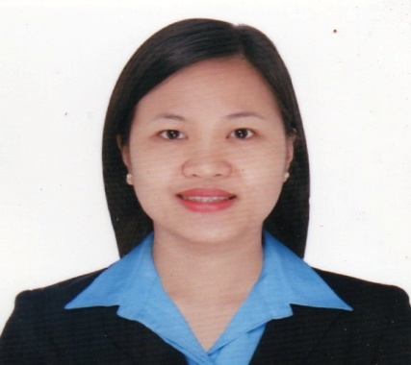
JOY
Doha, Qatar
C/o- +971504973598
Joy.345035@2freemail.com

CAREER OBJECTIVE:
To obtain a position that will enable me to use my knowledge in accounting.

SUMMARY OF QUALIFICATIONS
- Over 7 years of work experience with background in accounting and auditing.
- A flexible professional who can easily adapt to a new environment and can deal with different kind of people.
- Self-motivated, hardworking and trustworthy.

PERSONAL INFORMATION
Nationality: Filipino
Birth Date: March 15, 1984
Gender: Female
Marital Status: Single

PROFESSIONAL EXPERIENCES
September 2016 - Present

Position: Personal Accountant to the CEO
Employer: Staff Source International – Doha, Qatar

- Look after all the investments of the CEO.
- Set up accounting system for the newly opened businesses.
- Handle all the financial transactions of the CEO.

April 2015 – August 2016

Position: Accountant
Employer: Qatar Maid Service/Staff Source International–Doha, Qatar

- Prepare monthly financial reports of the 2 companies for the management.
- Record and review the daily transactions of the 2 companies.
- Monitor the daily cash position of the companies’ bank accounts.
- Handles cheque issuances for disbursements.
- Handles petty cash fund.
- Review accounts payable and arrange for payments.
- Prepare lapsing schedule for fixed assets.
- Prepare schedule for annual audit.

May 2013- April 2015

Position: Accounting Staff
Employer: San Andres Fishing Industries, Inc. - Philippines

- Prepare monthly bank reconciliation.
- Make adjusting entries regarding cash transactions when needed
- Prepare lapsing schedule for the company’s fixed assets.
- Reconcile the balances of the fixed assets subsidiary ledger to the general ledger.
- Record monthly depreciation for all fixed assets.
- Prepare schedules relating to fixed assets and bank reconciliation for annual audit.

October 2012- April 2013

Position: Accounting Staff
Employer: San Andres Fishing Industries, Inc. – Indonesia Branch

- Monitordaily cash on hand.
- Prepare invoices for accounts receivable and collect on due date.
- Handle accounts payable and arrange for payments.
- Monitor employees’ cash advances.
- Computeand distribute staff incentives.
- Preparemonthly sales report, summary of expenses and cash flow with attachments and send to main office.
- Act as a purchaser in the absence of the purchasing officer.
- Assists in the operation department in the absence of the operation in charge.
- Develop harmonious relationships between employees.
May 2012- October 2012
Position: Accounting Staff
Employer: San Andres Fishing Industries, Inc. - Philippines

- Prepare cheque voucher for company’s disbursements.
- Enter disbursement transactions in the accounting system.
- Prepare lapsing schedules for company’s fixed assets.
- Record fixed assets acquisitions and dispositions.
- Reconcile the balances of the fixed assets subsidiary ledger to the general Ledger.
- Record monthly depreciation for all fixed assets.
- Prepare schedules relating to fixed assets and check vouchers for annual audit.

June 2010 – May 2012

Position: Audit Staff
Employer: San Andres Fishing Industries (Prime Holdings)-Philippines

- Execute process review for the designated affiliated company.
- Review and analyze the process and make recommendations when needed.
- Execute financial audit.
- Prepare audit report addressed to the audit head after financial audit of the assigned accounts.
- Observe inventory count of an affiliated company at year end.
- Assists the accounting department of an affiliated company that needs assistance.

February 2010 - May 2010

Position: Accounting Staff
Employer: Toyota General Santos - Philippines

- Review and encode daily sales report to the accounting system.
- Monitors petty cash fund.
- Review cashier’s report daily and execute cash count before bank deposit.
- Prepares cheque and cheque voucher in the absence of the assigned personnel.

October 2008 – February 2009

Position: Accounting Clerk
Employer: Decoarts Marketing - Philippines

- Review and enter daily sales report of five branches to the accounting system.
- Coordinate with branch cashiers/head when problem arises.

EDUCATION
March 2007 Bachelor of Science in Accountancy
Ramon Magsaysay Memorial Colleges
General Santos City, Philippines
AWARDS:
- Excellence in Accountancy Studies (Gold Medalist)
- Service Awardee

AFFILLIATIONS

A.Y. 2006-2007 President A.Y.2005-2006 Vice President
Junior Philippine Institute of Accountants
Ramon Magsaysay Memorial Colleges Chapter
General Santos City, Philippines

SEMINARS ATTENDED

August 1, 2014 Succeeding Business
Regional Tripartite Wages and Productivity Board XII
National Wages and Productivity Commission
Department of Labor and Employment
General Santos City, Philippines

April 27, 2012 Fraud Investigation and Dispute seminar
SGV
Davao City, Philippines

