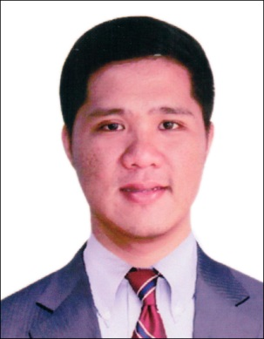
Raymond
Registered Electronics Engineer/Software Engineering Analyst
C/o-Mobile No.: +971501685421
Raymond.345049@2freemail.com

Profile Summary

- 3 years within Accenture and has been assigned for 2 projects.
- Experience in SAP Security Administration
- Experience in SAP Portal Administration
- Experience in SAP Basis Administration on numerous server environments
- Experience in SAP Production/Non-Production Support
- Experience in SAP - Oracle / UNIX and Oracle/ Windows platform.
- Experience in 3rd Party tool (CPS Redwood) for SAP

Work Experience

Company: Accenture
Duration: November 2013 – January 2017
Position: Software Engineering Analyst

Responsibilities:

- Ensure sap systems availability and performance for production and non-production environment
- Fix/Report system errors encounter on system health check monitoring – Check for hanging or stopped work processes, system log for errors/warnings, lock entry list, etc.
- Perform system start/stop
- Perform SAP Database Administration – Space management, File system housekeeping, Backup checking and troubleshooting
- SAPGUI/SAPLGPAD troubleshooting and maintenance.
- Job scheduling and cancellation at sap level or using 3rd party tool CPS-Redwood
- Analyses of early warning reports and take necessary preventive action.
- Problem resolution related to SAP BASIS
- SAP user access provisioning (creation, deletion and role addition) for production and non-production environment
- Resolved many missing authorization issues by analyzing the SU53 screen shots.
- Resetting passwords and Locking/Unlocking User Accounts
- Coordinating with the functional and business team.
- Upgrades/Migrations

Company: University of the East (Manila)
Duration: December 2011 – May 2012
Position: Casual Employee

Responsibilities:
- Install and perform minor repairs to hardware, software, and other equipment.
- Set up equipment for employee use, performing or ensuring proper installation of cable, operating systems, and appropriate software.
- Maintain record of daily data communication transactions, problems and remedial action taken, and installation activities.
Company: Microsourcing
Duration: May 2011 – October 2011
Position: Measuring Technician

Responsibilities:

- Conduct Aerial measurement of roof/s of any structure.
- Make a 3D model of roof/s of any structure.

Educational Background

UNIVERSITY OF THE EAST CALOOCAN
College of Engineering
Samson Road, Caloocan City
Course: BS Electronics and Communications Engineering
AY 2005 – 2010

Training/Continuing Education

- SAP HANA Administration
Accenture
- PDC SAP BASIS Industrialized Bootcamp
Accenture
- PDC SAP BI Industrialized Bootcamp
Accenture
- Consumer Electronics Servicing NC II
St. Peter Velle Technical Training Center, Inc.

