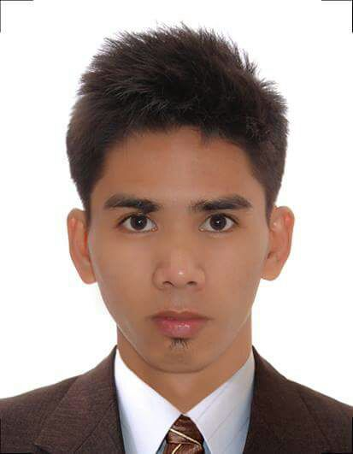
SANDRO
SANDRO.345062@2freemail.com

CAREER OBJECTIVE:

To be part of an organization where I could bring out and utilize my potentials, skills and knowledge as well as providing me with personal and professional advancement.

STRENGTHS AND TECHNICAL SKILLS:

- Minor Machine Troubleshooting
- Proficient in Microsoft Office (Word, Excel and PowerPoint)
- An excellent team player and can communicate well to all level of organization.
- Highly Trainable, Fast learner, Dynamic, Innovative and Competent
- Ready and willing to face any challenges and responsibilities
- Can work under pressure, utilizing available and limited resources
- Self-motivated
- Possess initiative and Highly energetic

WORK EXPERIENCES:

LOGISTIC COORDINATOR | ASSOCIATE STAFF
LITTLE FUSE PHILIPPINES
LIMA TECHNOLOGY CENTER
Malvar Batangas, Philippines
June 2016 – December 2016

PRODUCTION PLANNING INVENTORY CONTROL
PHILINAK INDUSTRIES INCORPORATED
LIMA TECHNOLOGY CENTER
Malvar Batangas 4233, Philippines
August 7, 2015 – Dec 18, 2015

Tasks and Objectives:
- Establishing and controlling inventory and prompt shipments of all incoming raw materials and in timely monitoring delivery of goods
- Conforms discrepancy report and receiving reports.
- Records total delivery on receiving report
- Receives orders delivered by the supplier
- Performs inventory controls and keep quality standards high for audits
- Completes data recorded into inventory

- Reports data discrepancies
- Communicates and cooperates with supervisors and co-workers
- Operates and maintains preventively warehouse vehicles and equipment
- Follow quality service standards and comply with procedures, rules and regulations
- Receives goods delivered to the warehouse for storage
- Unloading raw materials from the trucks and double-check to ensure accuracy with delivery documents
- Issuing correct parts withdrawn by the production
- Keeping a clean and safe working environment and optimize space utilization
- Knows how to use SAP Inventory System database
- Operates forklift

PRODUCTION AND MACHINE OPERATOR
PILIPINAS KYUHRITSO INC,
Inusluban Lipa City, Philippines
June 18, 2012 - January 10, 2013

Tasks and Objectives:
- Performs daily 6’s to being neat and orderly in an area as part of my daily routine.
- Have enough knowledge on how to operate the machine WP-JP1 (Wire Prep Jam production 1)
- Performs Daily Checking of machine condition
- Performs Standard Operating Procedures (SOP’s) on equipment operations (i.e. machine setting, measure the specs of the terminal harness, etc., and ensures, keeps track and/or addresses issues affecting machine efficiency.
- Seeks improvements on machine and process and conduct audit justify.
- Proper and daily checking of EPO check sheets which is ensuring proper use of terminals and wires.
- Expertise in 100% inspection of terminals and wires before proceeding to MI (Middle Inspector).

EDUCATIONAL ATTAINMENT:

Tertiary: Kolehiyo ng Lungsod ng Lipa
Diploma in Computer Technology
June 2013 – April 2015

Secondary: Inusluban Marawoy National High School
June 2004 – March 2008

Primary School: Sto. Toribio Marawoy Elementary School
June 1998 – March 2004

SEMINARS AND TRAINING ATTENDED:

- TIMEKEEPER
UGNAYAN-SECURITY AGENCY
OJT – On the Job Training
November 18, 2015
- Updating Daily Duty Orderly
- Updating and encoding Security Payrolls and License

- SEMINAR WORKSHOP
Kolehiyo ng Lungsod ng Lipa

- TRILINK TRAINING AND DEVELOPMENT CORPORATION
TESDA Lipa City, Batangas

- DISCIPLESHIP TRAINING
Good Shepherd Worship Center Inc. - TARLAC
May 2014

- POPULATION EDUCATION AND ENDLESS ISSUE
March 28, 2014

- TESDA-Bartending
Technical Education and Skills Development Authority
July 5, 2010

AFFILIATIONS:

- GOOD SHEPERD WORSHIP CENTER INC. Lipa
Youth Councilor, May 2010 - April 2015

- CWTS, KOHELIYO NG LUNGSOD NG LIPA
Volunteer, September 2013 - January 2014

OTHER PERSONAL INFORMATION:
Age: 26 years old
Date of Birth: May 13, 1991
Birthplace Occidental Mindoro
Civil Status: Single
Nationality: Filipino
Religion: Christian
Visa Status: Tourist Visa

